MODEL
SEN 1500
BLOWING CONVEYOR OVEN
(DIJITAL SCREEN)
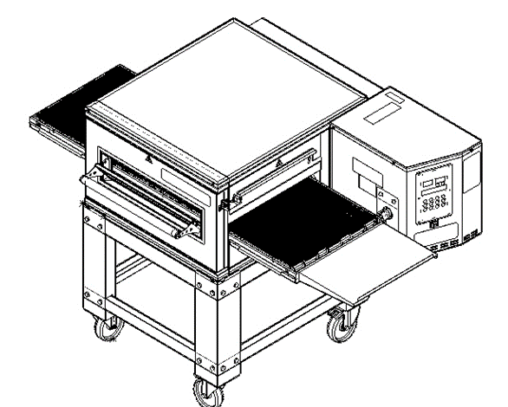

USER & MAINTENANCE MANUAL

ŞENGÜN MAKİNA İNŞAAT ve KIRTASİYE SAN. TİC. LTD. ŞTİ

These instructions apply only if the country code is shown on the device. If the country code does not appear on the device, refer to the technical instructions that give instructions for adapting the device to the country.

This device must be installed in accordance with regulations. Refer to the instructions before installing and using the device.


WARRANTY CERTIFICATE
SERIAL NUMBER :
SALE DATE :
Sold at the above date SEN 1500 MODEL BLOWING CONVEYOR OVEN is guaranteed against production failures for 1 Year by ŞENGÜN MAKİNA İNŞAAT ve KIRTASİYE SAN. TİC. LTD. ŞTİ.

Warranty Terms;
- Warranty terms start after the product delivery for 1 year.
- Recommended daily working time is 10 hours. The scope of warranty is assessed by year or by working hours.
- Documents are invalid, if haven’t sale date and confirm signature of company. You have to show the warranty certificate to benefit from the warranty.
- Device is guaranteed against defects if mount and use as described ın the use and maintenance manual.
- Detection the location of defects, and elimination of the problems are responsibilities of the ŞENGUN MAKİNA…
- Warranty terms includes only one device. You can’t claim any rights or compensation for another devices.
- If Changes are made at the type, model and serial numbers, the warranty eliminates.
- If material, worker or assembly defects appear, repaired free by ŞENGÜN MAKİNA at the product warranty period (Transportation cost is not included).
- Failures are only repaired by ŞENGÜN MAKİNA’s personal. The intervention of unauthorized person, cancel the appliance of warranty.
- Installation have to be done by ŞENGÜN MAKİNA’s personal. İf usage place changes, customer must give information to ŞENGÜN MAKİNA
- In the event of failure service must be informed.
- The failures and damages given by external factors are out of the warranty terms.
- Any failure of the product warranty period is added to the product warranty time. The repair time is until 20 working days.
- Istanbul courts are competent in case of dispute.
AUTHORIZED PERSON
STAMP –SIGNATURE

PRESENTATION

Dear Users,
Thank you for your prefer our machine and confidence in our company. Our machines are used in 39 countries.
Our machine is manufactured according to international standards. Please read the operating manual to get the mast out of your machine .Please note the following warnings before calling our service.

ŞENGÜN MAKİNA

- Please read the manual carefully before installing the machine.
- The machine will be out of warranty when your operate the machine with at read.
- Please read carefully the manual that gives you information on the installation is prepared in accordance with the legal regulations before arriving at the machine installation.
- For information you coo not understand , ask your nearest out horized service
- Please note that if the technical service personnel is kept waiting you will be billed for each hour.

IMPORTANT WARNINGS AND SAFETY INFORMATIONS
 WARNING: This manual contains important safety and installation-operation instructions. Require all operators to read this manual thoroughly before installing, operating or servicing this equipment. Improper installation, adjustment, alteration, service or maintenance can cause property damage, injury or death.
WARNING: This appliance is not intended for use by young children or infirm persons unless they have been adequately supervised by a responsible person to ensure that they can use the appliance safely. Young children should be supervised to ensure that they do not play with the appliance.
WARNING: Improper installation, adjustment, alteration, service or maintenance can cause property damage, injury or death. Read the installation, operating and maintenance instructions thoroughly before installing or servicing this equipment.
WARNING! Do not work around conveyor belt with long hair, loose clothing, or dangling jewelry. Getting caught in the belt could result in serious injury.
WARNING! For your safety, do not store or use gasoline or other flammable vapors or liquids in the vicinity of this or any other appliance.
 WARNING! If the power supply cord damaged, do not attempt to operate the unit. Contact a service agent or qualified electrician to repair!
WARNING! Do not use paper when placing food product through the oven! Usage of flammable materials may cause a fire and should never be placed in the oven.
WARNING! Do not put any object to anywhere of the oven except the conveyor.
WARNING! Always be careful while you are working.

- The oven must be placed under a ventilator to provide for adequate air supply.

- Minimum clearances must be provided from all walls and combustible materials. Look “spacing requirements” section for more information.

- Always keep the oven clean and clear combustible materials.

- Keep adequate clearance for air openings.

- Do not obstruct the ventilation holes.

- The oven is to be operated only on as shown on the specification plate.

- This manual should be retained for future reference.

- Prepare a list of what you should do when you smell gas and keep it near the oven.
- Gas does not pass through the burner without electricity.

Responsibilities of the Purchaser Company
Responsibilities of the purchaser company are written at bottom;
- To see that the electric and gas services for the oven are installed in accordance with the manufacturers specification.
- İnstalling the oven and placing it as suggested at the catalogue.
- To see that the electric services are connected properly by a qualified installer of your choice.

WARNING

Cleaning and maintenance are the most important factors of oven performance. The processes which are not available in the manual can cancel the appliance of warranty, cause property damage, injury or death. Read and understand the instructions in the manual

WARNING

Cleaning and maintenance are the most important factors of oven performance. The processes which are not available in the manual can cancel the appliance of warranty, cause property damage, injury or death. Read and understand the instructions in the manual

CONTENTS
WARRANTY CERTIFICATE

PRESENTATION

SECTION 1: INTRODUCTION
1.1 Introduction of Body Components
1.2 Functions of Parts
1.2.1 Oven Body
1.3 Overlap Assembly
1.4 Microprocessor Control
1.5 Cooking Function
1.6 Conveyor (Belt)
1.7 General Information
1.8 Oven Specifications
1.9 Electrical and Technical Specifications Table
1.10 Dimensions

SECTION 2: ASSEMBLE
2.1 Product Out Sheet
2.2 Front/Back Waste Collecting Sheet
2.3 Entry and Exit Cover Sheet
2.4 Stopper Sheet (Optional)
2.5 Belt Assembly
2.6 Belt Wire Assembly
2.7 Hıgh Chassis Assembly
2.8 Low Chassis Assembly
2.9 Chassis-Oven Assembly
2.10 Double Floor Oven Assembly
2.11 Triple Floor Oven Assembly
2.12 Air Duct Disassembly / Assembly

SECTION 3: INSTRUCTIONS FOR USE
3.1 Distance Requirements
3.2 General Information of Ventilation
3.3 Ventilation Advice
3.4 Installation Elements
3.5 SEN 1500 Oven Technical Specifications Table

SECTION 4: PROGRAMMING-START & STOP
4.1 Warnings
4.2 Closing
4.3 Functions
4.3.1 Temperature cutting switch
4.3.2 Electrical Installation
4.3.3 Operator Installatıon
4.3.4 Cleaning Instructions
4.3.5 Preventive Maintenance
4.3.6 How to call technical service?

SECTION 5: COOKED PRODUCTS
5.1 Some of The Cooked Products
5.2 Cooking Time and Temperature
5.3 Total Cooking Calculation
5.4 Sample Capacity Table

SECTION 6: SPARE PARTS MANUAL

SECTION 7: ELECTRICAL DIAGRAM

SECTION 8: LABELS

NOTE

SECTION 1: INTRODUCTION
  - Introduction of Body Components:
OVEN CHAMBER
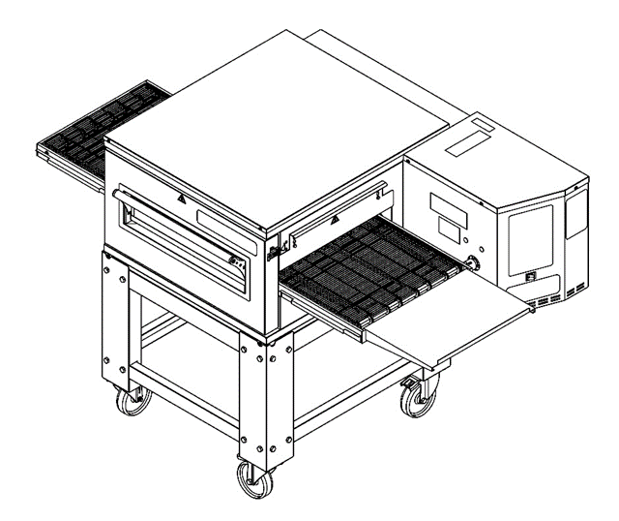
OVEN CHAMBER COVER
CONTROL BOX
CONVEYOR BELT
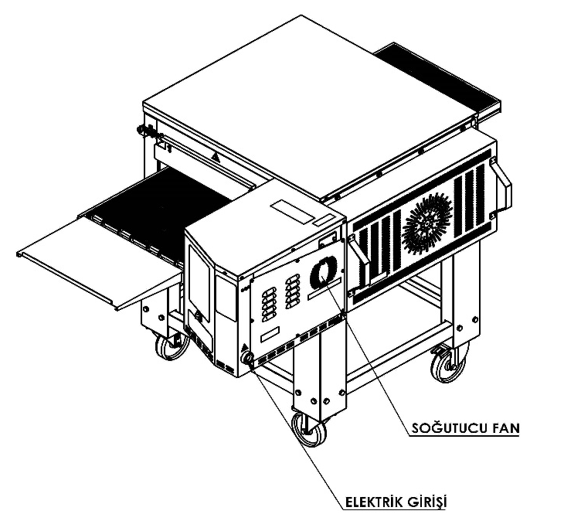
DIGITAL SCREEN

WINDOW
PRODUCT EXIT

STOPPER
COOLER FAN
CHASIS
ELECTRIC ENTRANCE
CONVEYOR BELT

NOTE: Entrance of product depends for the cooking style. The out sheet can be attached other side of the oven.

1.2 Functions of Parts:
1.2.1 Oven Body:
Every SEN series oven has a main body.

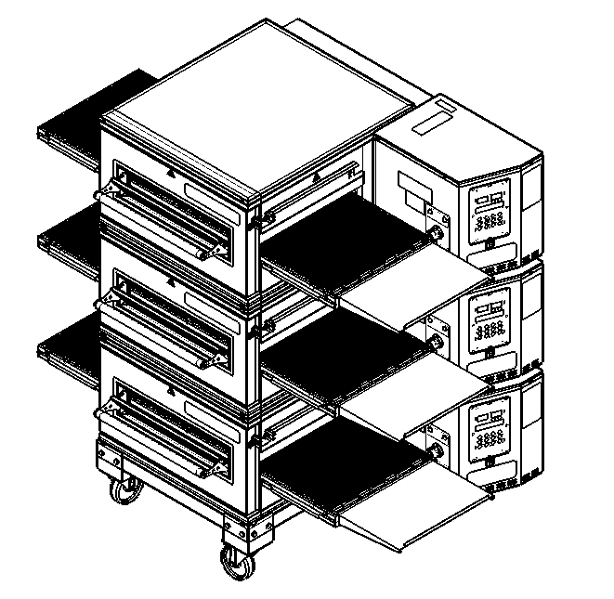
1.3 Overlap Assembly:

SEN series ovens can be used to overlap two or three. The ovens assembled to the chassis and connect each other.

1.4 Microprocessor Control:
Every single oven is controlled by separate programmable microprocessor. The microprocessor controls all functions of the oven. Oven temperature can be set between 90°C to 300°C. And the cooking time can be set between 1 - 30 minutes. Standby Mode provides energy saving. Also service module helps to the technicians. You can cook standard and delicious products in a short time.
1.5 Cooking Function:
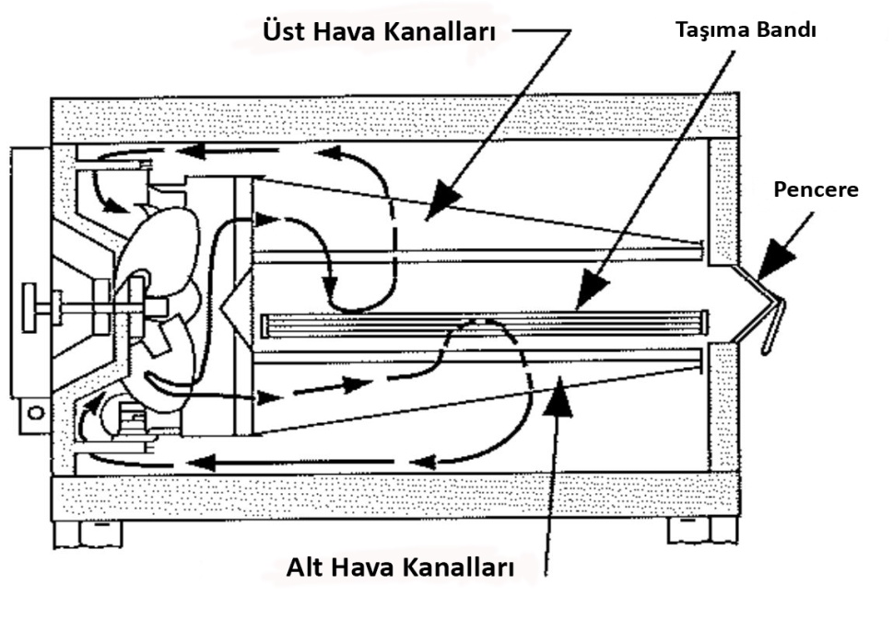
The oven cooks the products standard and delicious by circulating compressed air.
CONVEYOR BELT
AIR DUCT

WINDOW

AIR DUCT

1.6 Conveyor (Belt):
Conveyors provide the input and output of the product. Belt is controlled by microprocessor. Cooking time can be set between 1 - 30 minutes. The speed of belt determines the Products cooking time. The width of belt is 455 mm and consist by interlocking wires.

1.7 General Information:
- Information which are located at the following pages will guide you at installation of the oven.
- First of all check the parts of oven carefully.
- Before the installation determine a safety place for oven.

1.8 Oven Specifications:
 | SEN 1500
Conveyor Belt Width : | 455 mm
Heating Chamber Length : | 710 mm
Heating Chamber Size : | L 710 mm X W 486 mm x H 72mm
Conveyor Cooking Area : | 0,34 m²
Overall Dimensions for Single Oven : | Oven Width: 1043 mm  Oven Height: 450 mm  Total Long: 1710 mm
Overall Dimensions for Double Oven : | L 1710 x W 1043 x H 1165,5
Overall Dimensions for Triple Oven : | L 1710 x W 1043 x H 1615,5
Chassis Dimensions of the Single and Double Oven - Weight : | L 805 mm x W 720 mm x H 620 mm – 22,8 kg
Chassis Dimensions of Triple Oven - Weight : | L 805 mm x W 720 mm x H 265,5 mm – 14 kg
Weight : | 134 kg
Transportation Single Oven Weight – Domestic (Machine + Chassis + Packing) : | 195,3 kg
Transportation Single Oven Weight – Abroad (Machine + Chassis + Packing) : | 203,8 kg
Transportation Size (Domestic) : | L 1530 mm x W 1165 mm x H 675 mm
Transportation Size (Abroad) : | L 1470 mm x W 1110 mm x H 680 mm
Average Usage kW : | 4-5 kW
Allowable Temperature Range : : | 90 °C – 300 °C
Conveyor Drive System : | 208 - 300 Volt Microprocessor  Conveyor control system
Cooking Time : | 1 min – 30 min Adjustable
Insulation : | 4 Side
Heat Source : | 6 Heat source
Oven Chamber : | Steel (Galvanized)
Steel Enclosure : | 430 Stainless Steel
DB Level : | < 65 dba
Source : | Electricity

1.9 Electrical and Technical Specifications Table:
Electrical and Technical Specifications Table
Voltage | Faze | N | T (PE) | Cable Minimum Section | kW | Ampere Load
 |  |  |  |  |  | L1 | L2 | L3
400V 50/60HZ | 3 | 1 | 1 | 2,5 mm² | 10 kw | 14 | 14 | 15,5

NOTE: Specifications can be changed by Şengün Makina. Above Specifications are given for information.

1.10 Dimensions:
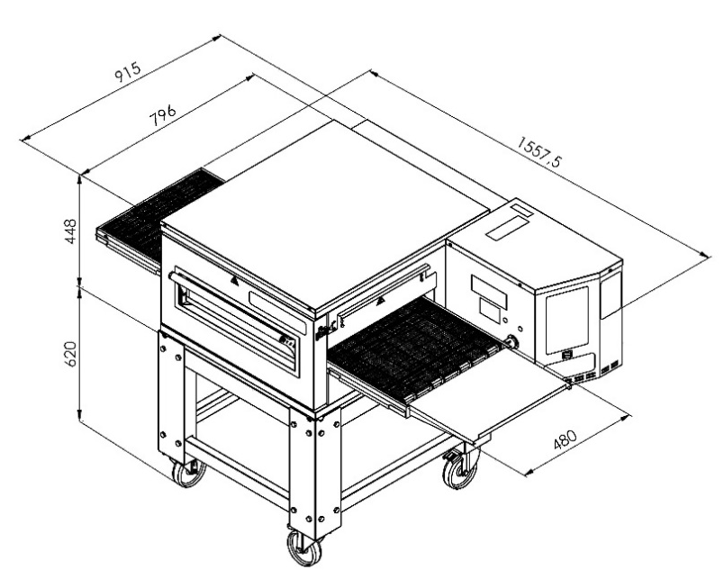
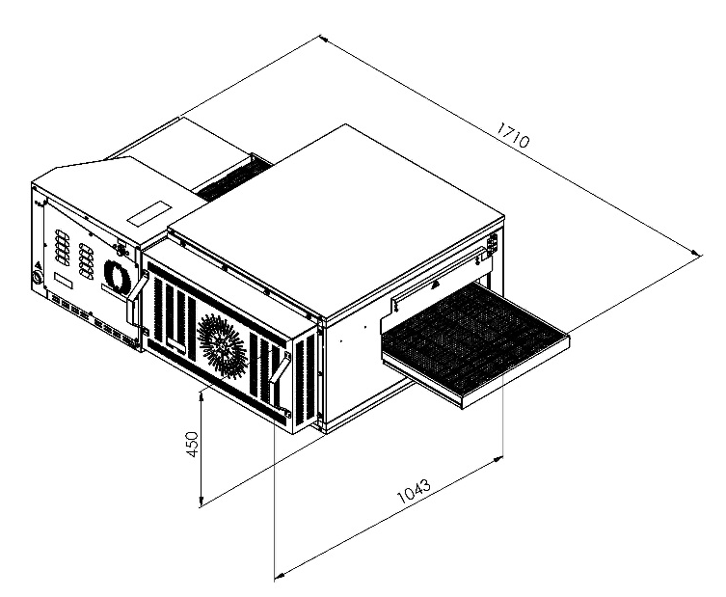

Dimensions Outside
Single Oven
(Isometric)

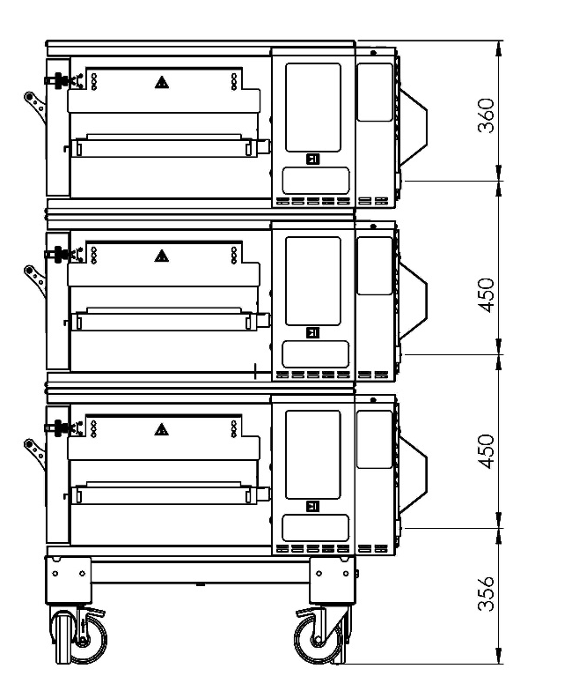
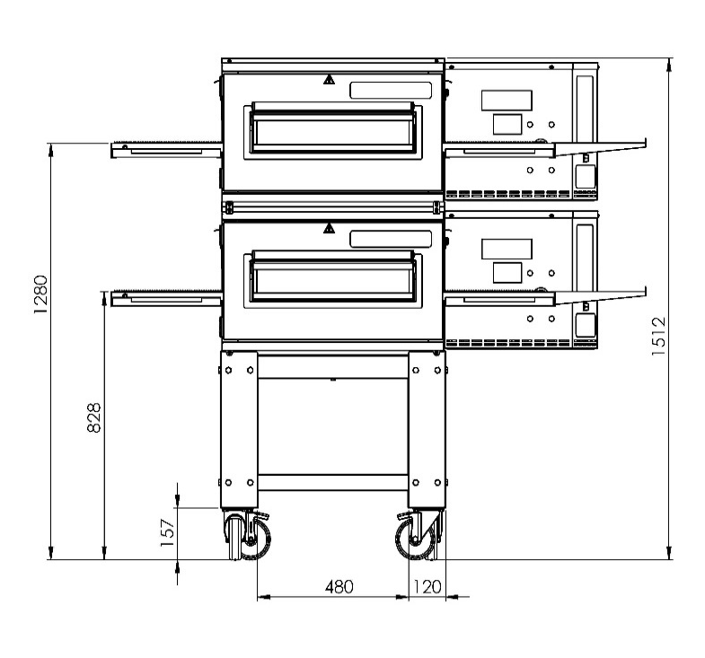
ELECTRICITY ENTRANCE DIMENSIONS

Front View
Duplex
(Side View)

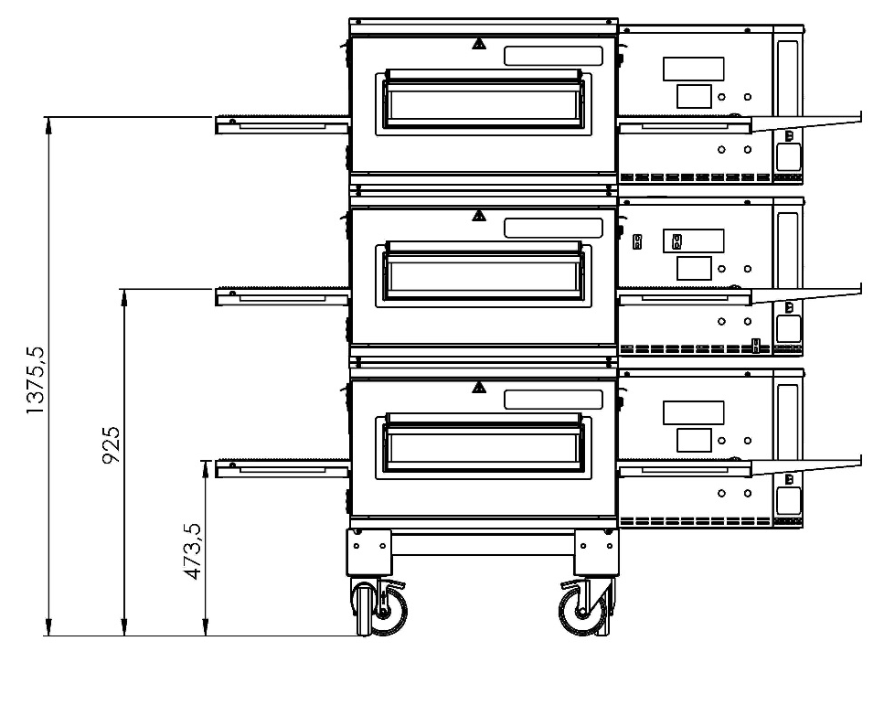

Triplex
(Side View)

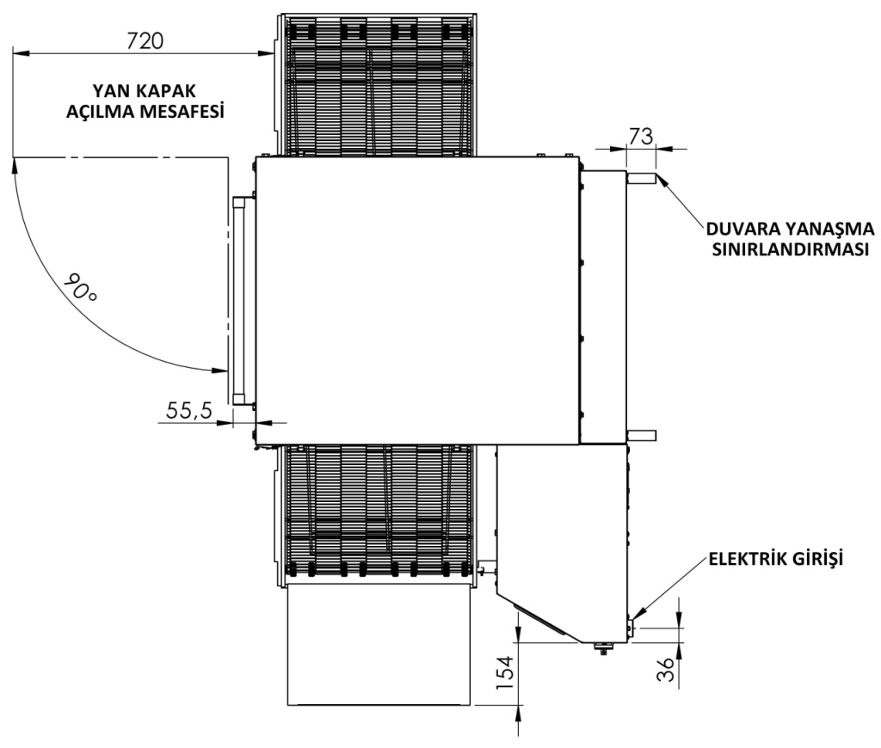
SIDE COVER
DISTANCE BETWEEN WALL

ELECTRICAL INPUT

Top View

SECTION 2: ASSEMBLE
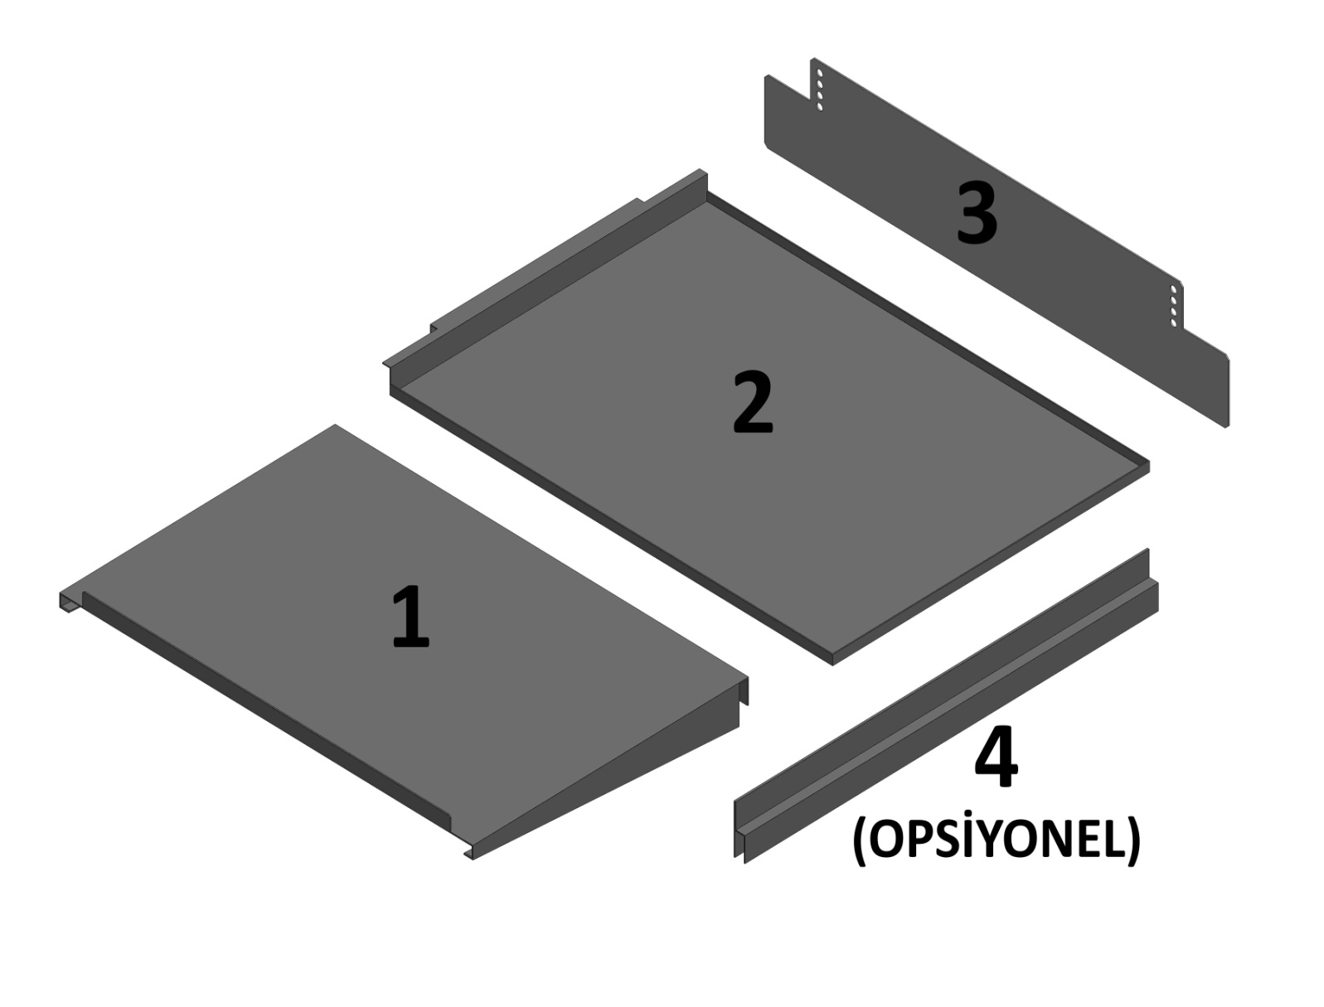
OPTIONAL

NO | PART NAME | UNIT
1 | Product Out Sheet | 1
2 | Forward/Back Waste Collecting Sheet | 2
3 | Entry and Exit Cover Plate | 2
4 | Stopper Sheet (Optional) | 1

2.1 Product Out Sheet:

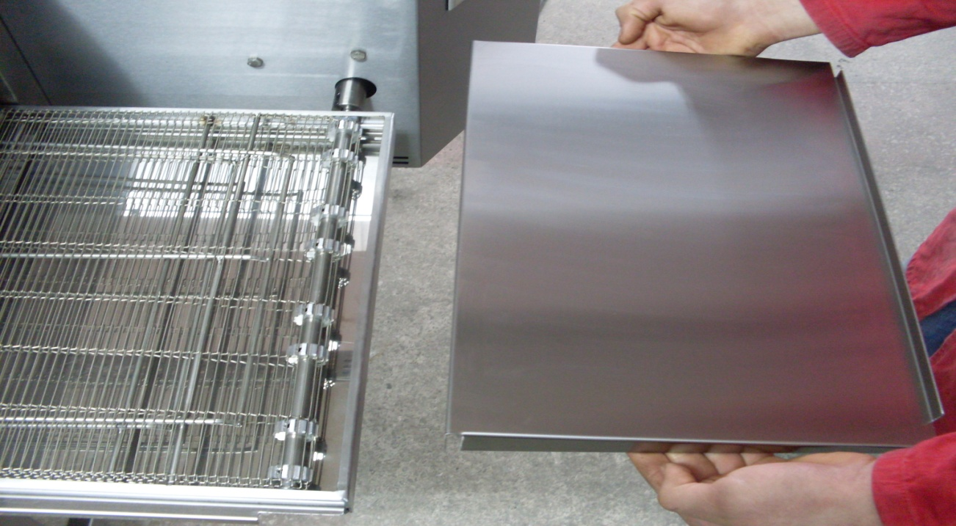
Attach the product out sheet to the conveyor chassis as shown in the figure. And Push it.

2.2 Front/Back Waste Collecting Sheet:
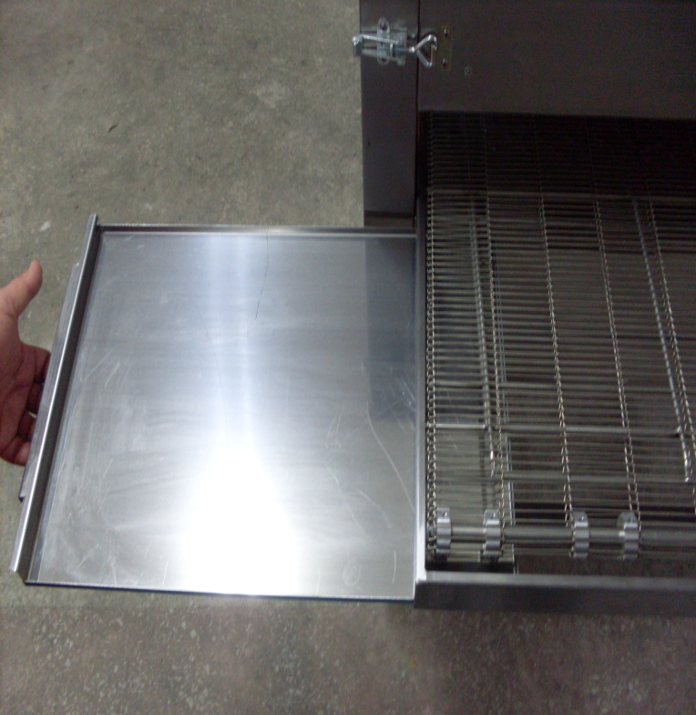
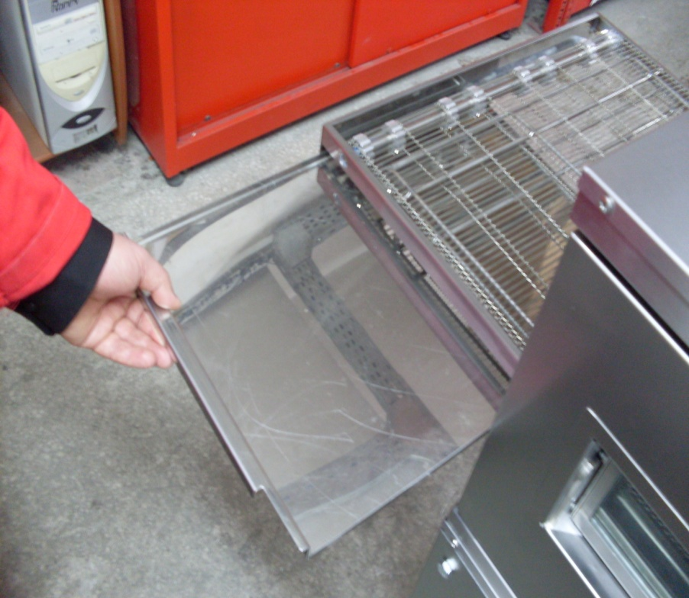

Front and back waste collecting sheets are taken out as shown in pictures.

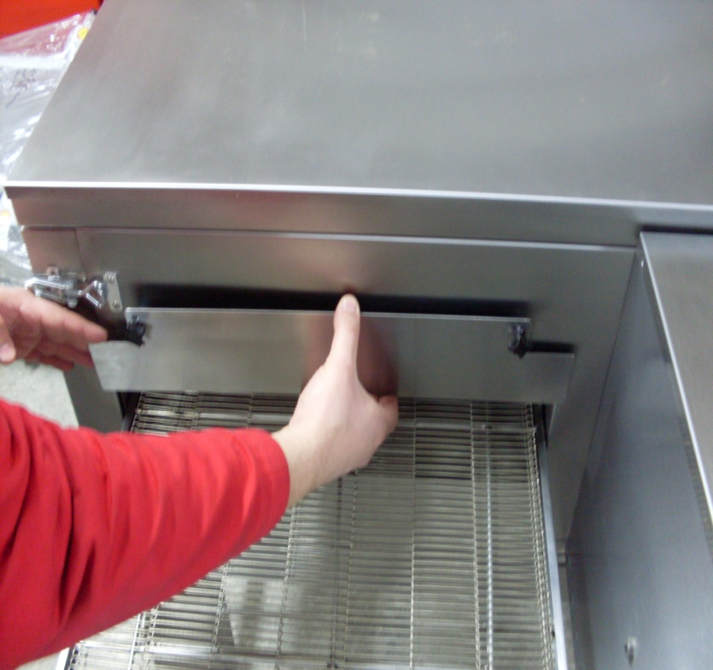
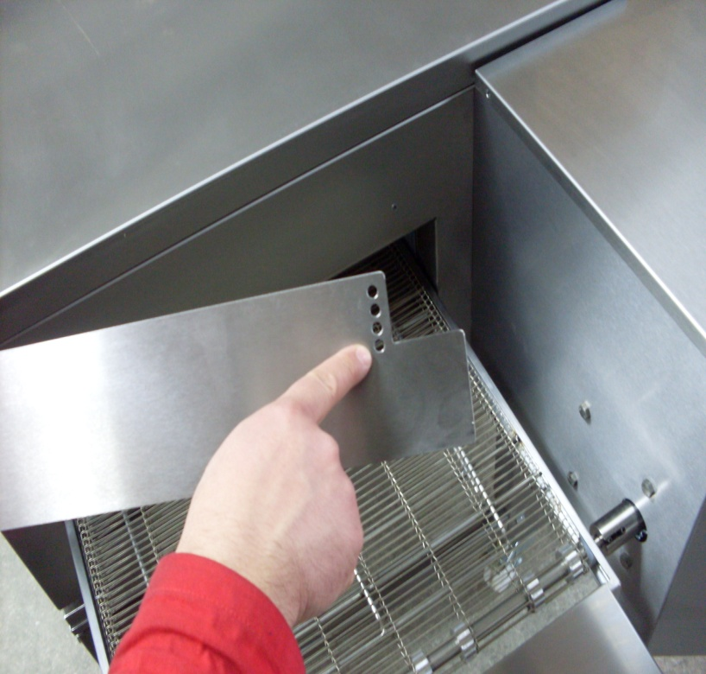
2.3 Entry and Exit Cover Sheet:

Covers are set as desired through holes which are different levels. Covers are attached by bakelite bolts.

2.4 Stopper Sheet (Optional):
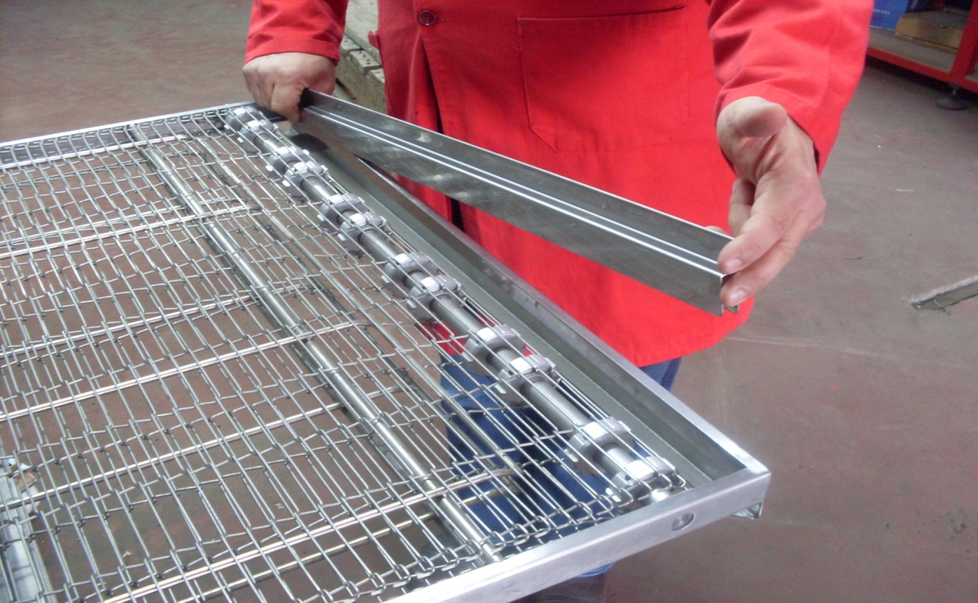

Stopper, blocks the products and keep them into the belt. Stopper is attached to the belt.

2.5 Belt Assembly:
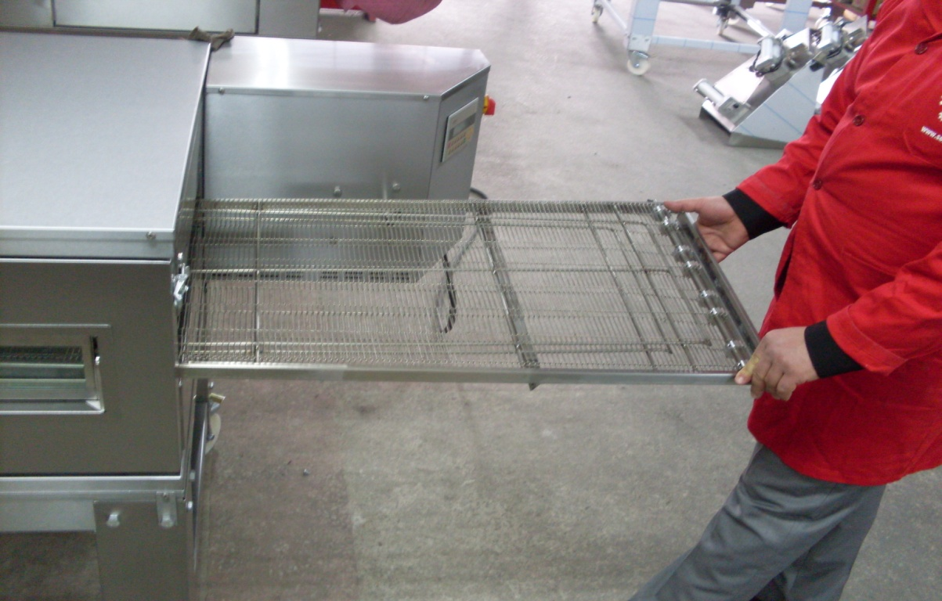

The conveyor is mounted inside the machine as shown in the picture.

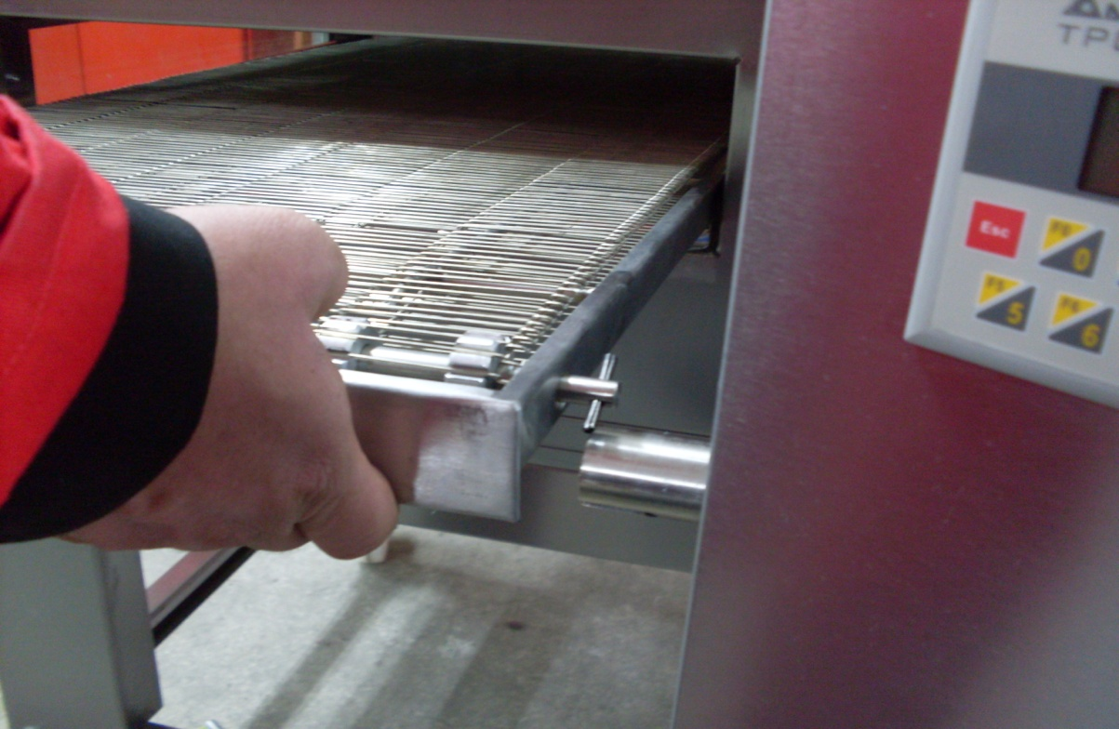

The drive shaft is centered on the clutch pipe.

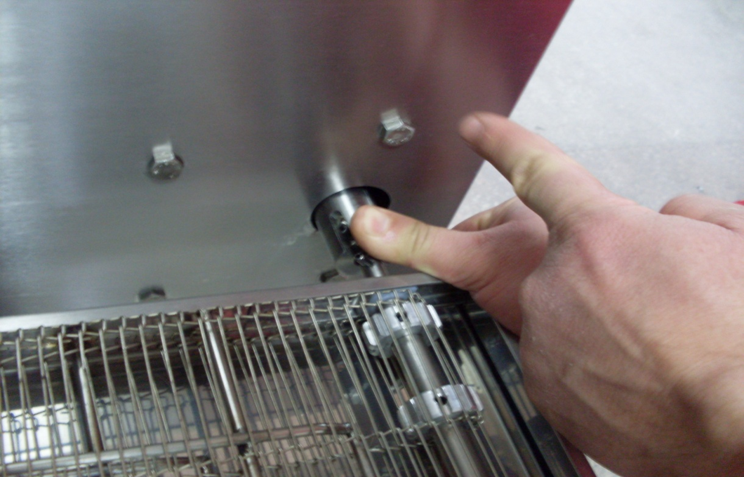

Clutch pipe is attached by the drive shaft spring as shown in the figure.
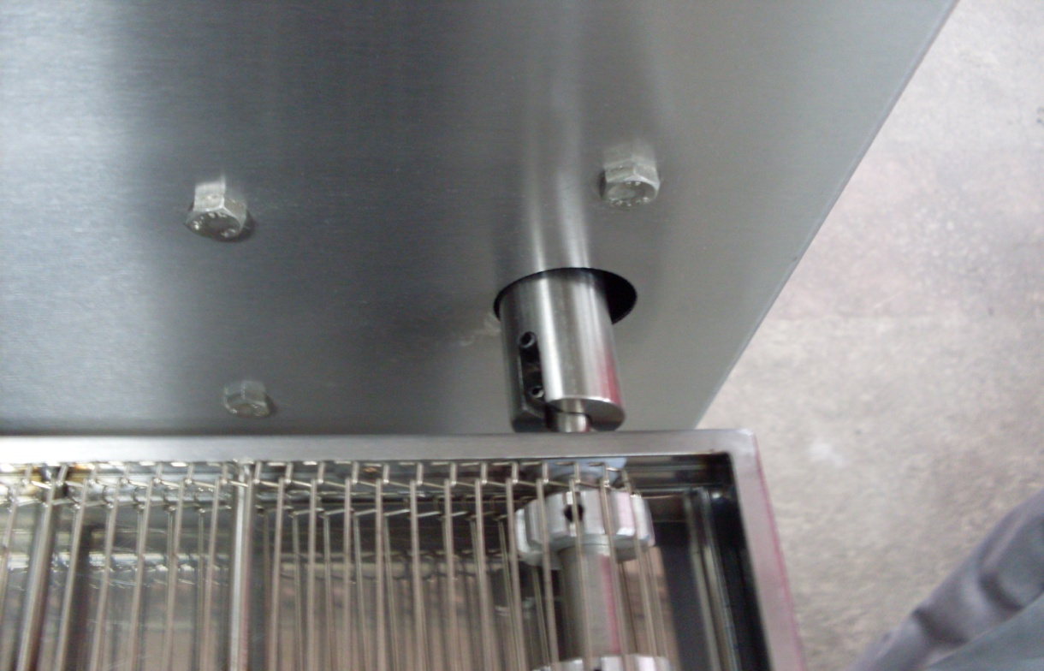

Belt assembly is completed. For disassembly, use every steps in reverse order.

2.6 Belt Wire Assembly:
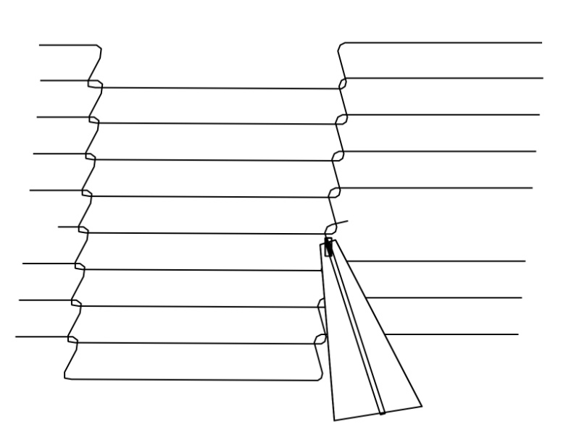
2. Attached by pliers (Middle connecting wire)

1. Installed as shown in the figure. (Edge connecting wire left and right)

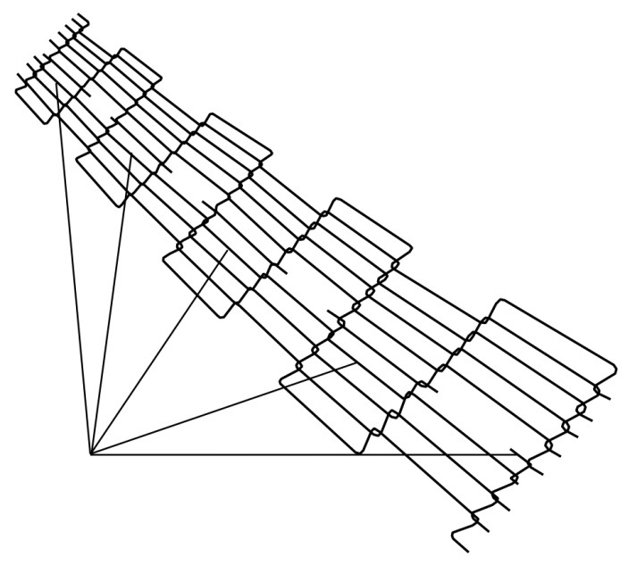

4. The final wire assembly
3. If belt wire problem appears, remove a wire as shown in the figure.

For disassembly, use every steps in reverse order.

NOTE: Clean the belt wire once a week or month for better performance.

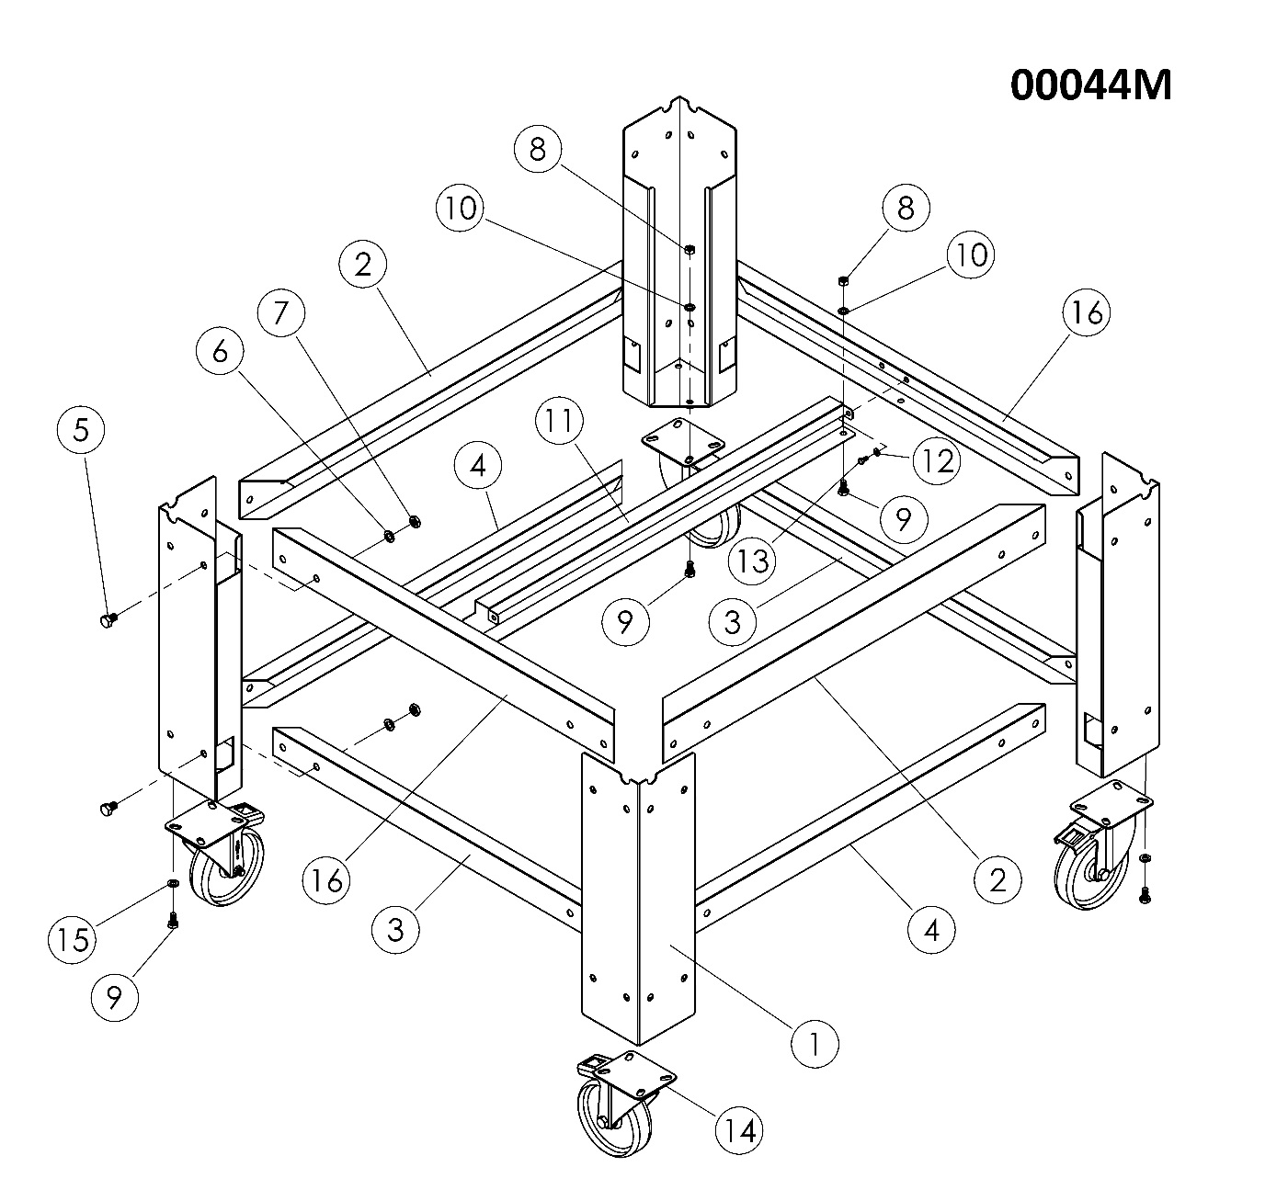
2.7 High Chassis Assembly:

SEN 1500 HIGH CHASSIS (L 805 mm x W 720 mm x H 620 mm) SPARE PARTS LIST
ITEM | SPARE PART NUMBER | SPARE PARTS DESCRIPTION | UNIT |  | ITEM | SPARE PART NUMBER | SPARE PARTS DESCRIPTION | UNIT
1 | 01981 | CHASSIS LEG SHEET | 4 |  | 9 | 01957 | BOLT | 18
2 | 01980 | BRACKET SHEET | 2 |  | 10 | 01961 | WASHER | 18
3 | 01977 | BRACKET SHEET | 2 |  | 11 | 01978 | BRACKET SHEET | 1
4 | 01976 | BRACKET SHEET | 2 |  | 12 | 00051 | WASHER | 2
5 | 01958 | BOLT | 32 |  | 13 | 00048 | BOLT | 2
6 | 01960 | WASHER | 32 |  | 14 | 01964 | WHEEL | 4
7 | 01965 | NUT | 32 |  | 15 | 01963 | WASHER | 16
8 | 01959 | NUT | 18 |  | 16 | 00043M | BRACKET SHEET GROUP | 2

2.8 Low Chassis Assembly: 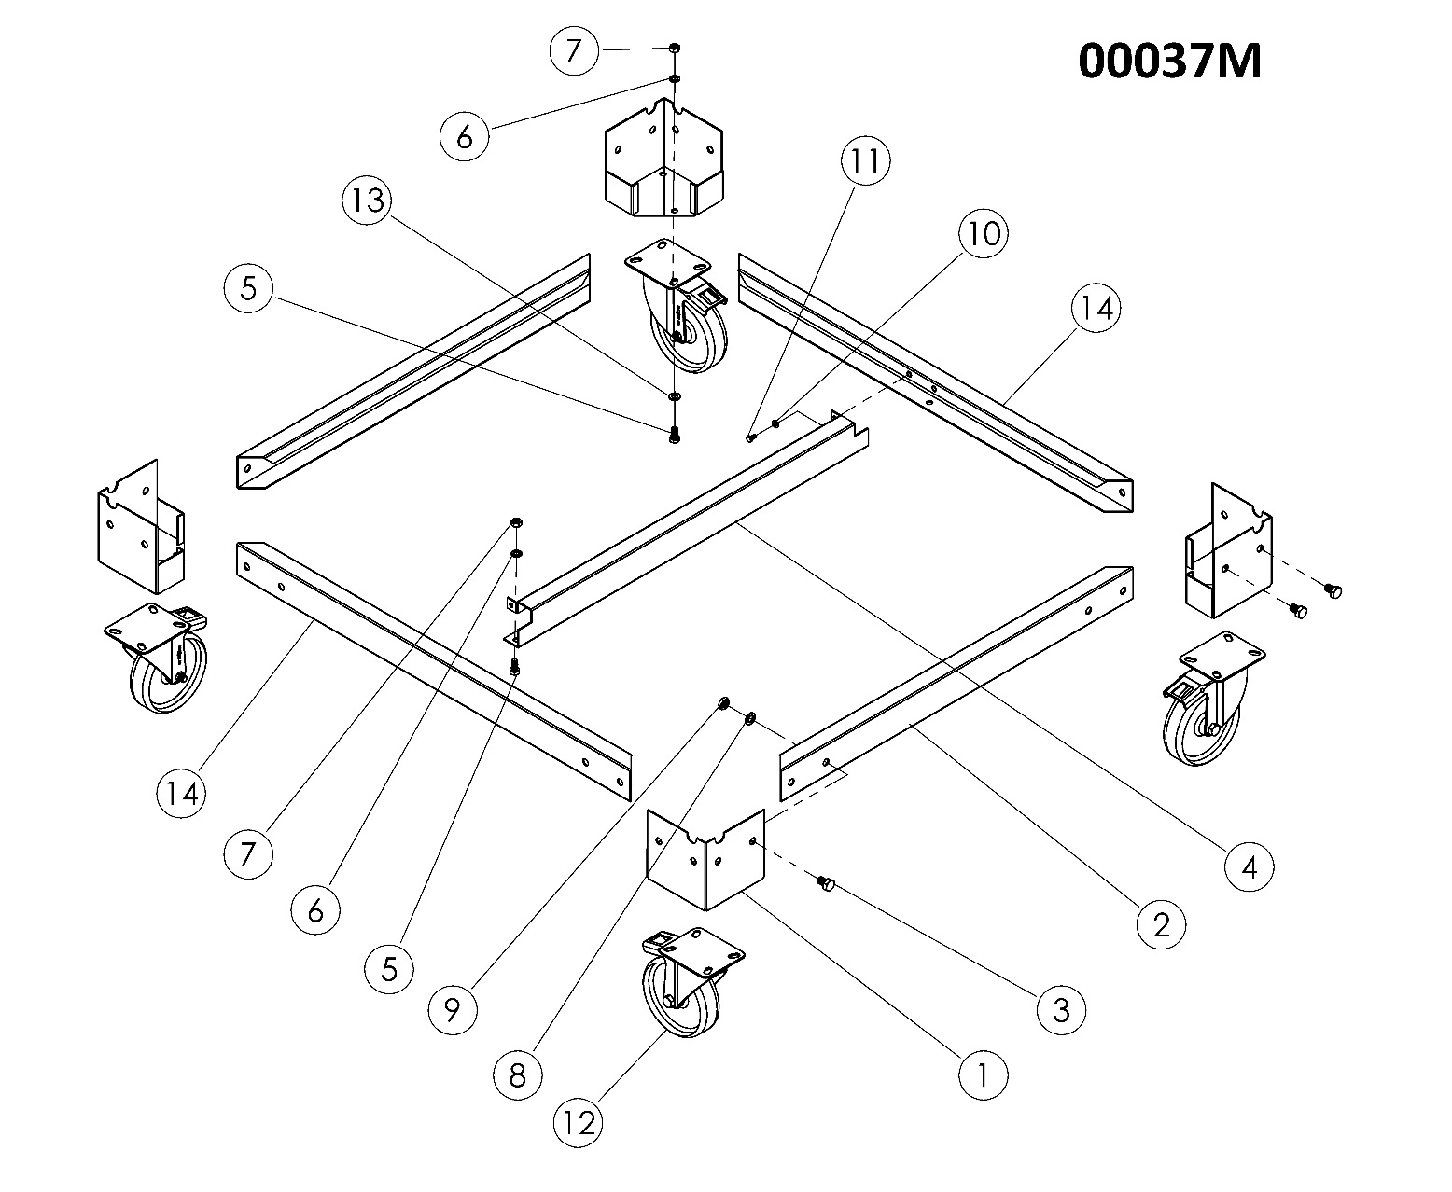

SEN 1500 LOW CHASSIS (L 805 mm x W 720 mm x H 265,5 mm) SPARE PARTS LIST
ITEM | SPARE PART NUMBER | SPARE PARTS DESCRIPTION | UNIT |  | ITEM | SPARE PART NUMBER | SPARE PARTS DESCRIPTION | UNIT
1 | 01797 | CHASIS LEG SHEET | 4 |  | 8 | 01960 | WASHER | 16
2 | 01809 | BRACKET SHEET | 2 |  | 9 | 01965 | NUT | 16
3 | 01958 | BOLT | 16 |  | 10 | 00051 | WASHER | 2
4 | 01842 | BRACKET SHEET | 1 |  | 11 | 00048 | BOLT | 2
5 | 01957 | BOLT | 18 |  | 12 | 01964 | WHEEL | 4
6 | 01961 | WASHER | 18 |  | 13 | 01963 | WASHER | 16
7 | 01959 | NUT | 18 |  | 14 | 00042M | BRACKET SHEET GROUP | 2

2.9 Chassis-Oven Assembly:

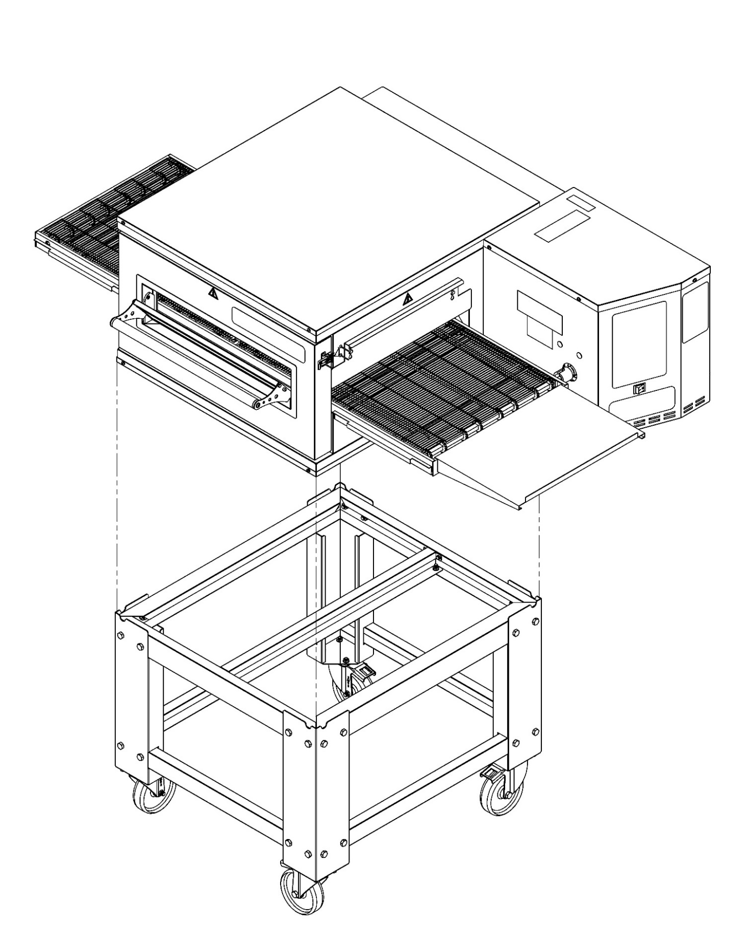

2.10 Double Floor Oven Assembly:

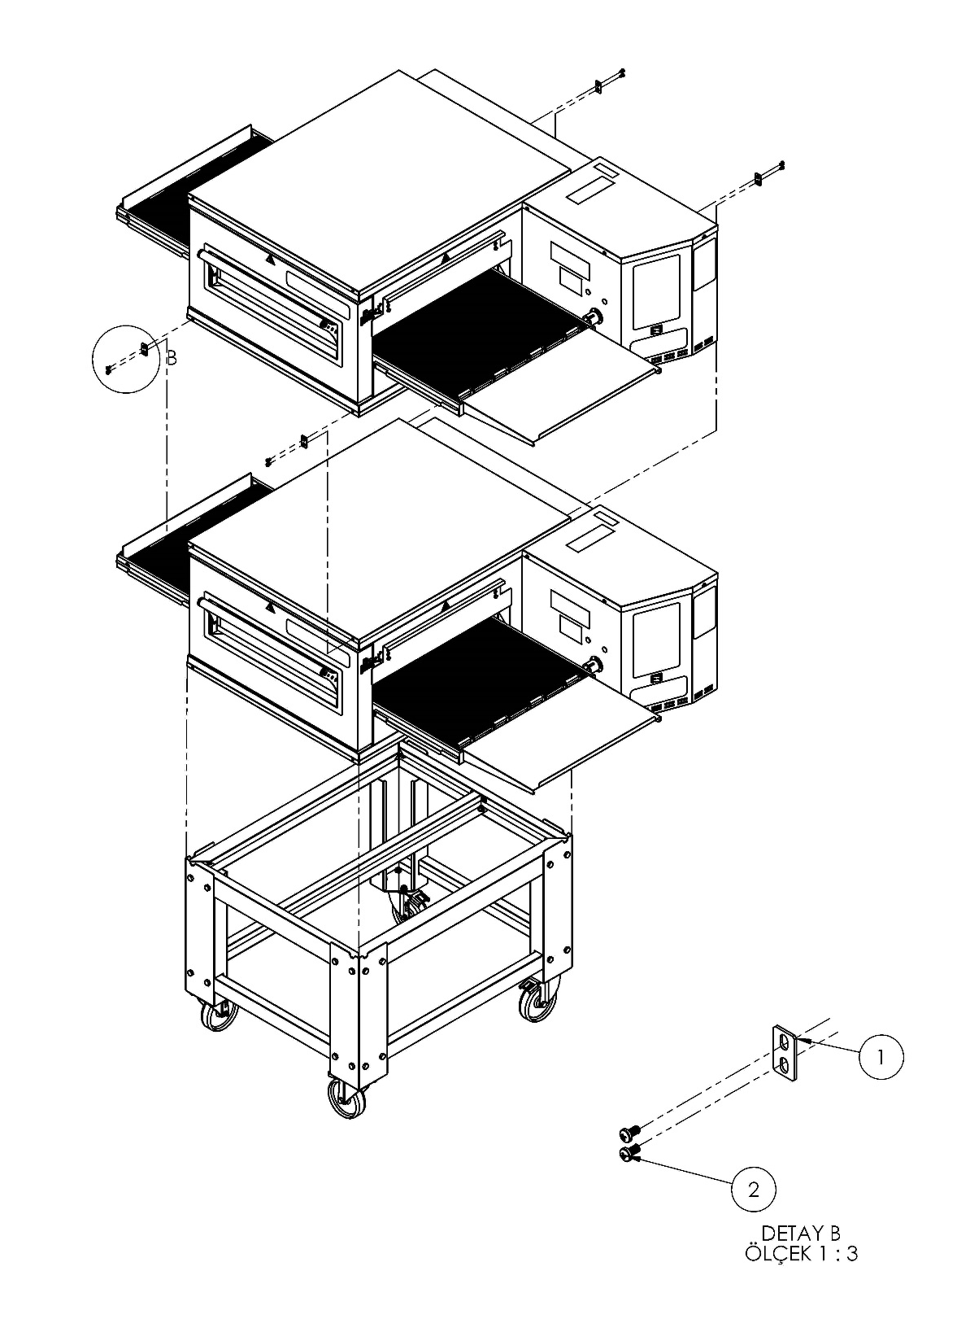

DETAIL B
SCALE 1:3

NOTE: Bolts are included in the package

ITEM | SPARE PART NUMBER | SPARE PART DESCRIPTION | UNIT
1 | 02056 | HOLDER | 4
2 | 00046 | BOLT | 8

2.11 Triple Floor Oven Assembly:
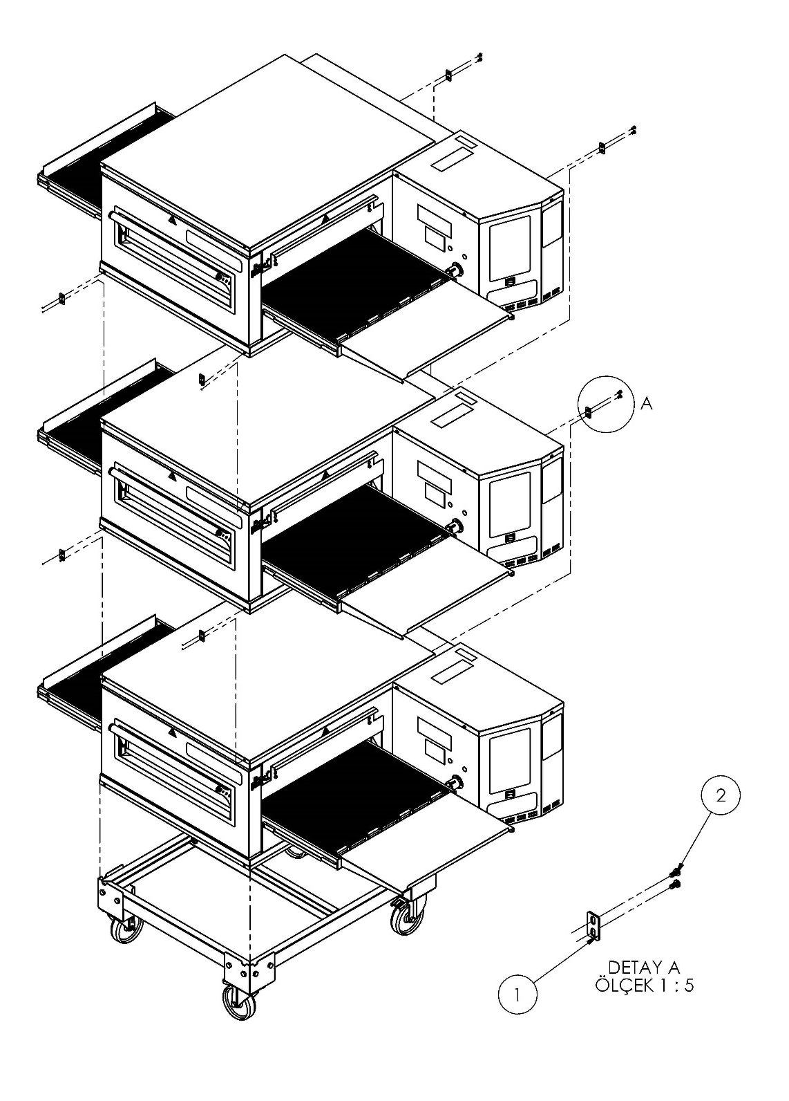

DETAIL A
SCALE 1:5

NOTE: Bolts are included in the package.
ITEM | SPARE PART NUMBER | SPARE PART DESCRIPTION | UNIT
1 | 02056 | HOLDER | 8
2 | 00046 | BOLT | 16

2.12 Air Duct Disassembly / Assembly:


WARNING! Wait for the cooling of the oven.

- Open the oven cover.

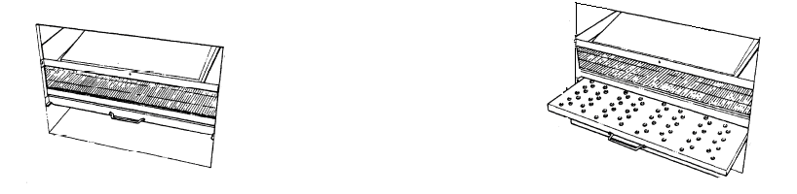
3. Hold the bottom air duct holder and pull it.
2. Hold the upper air duct guard sheet. Pull up the sheet and pull it.

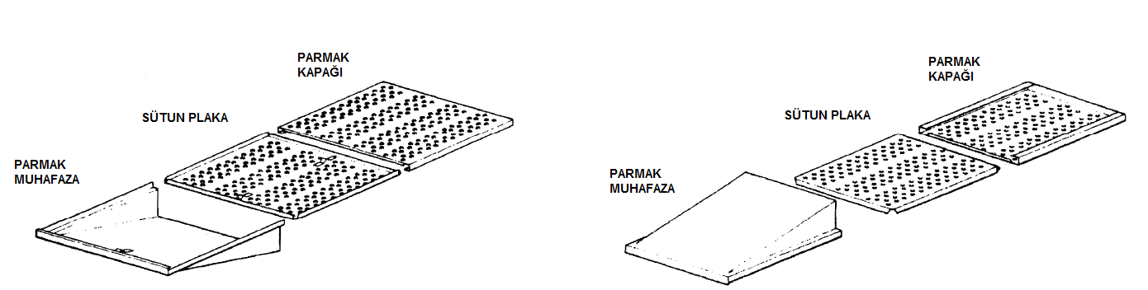
Finger Guard
Pillar Cover
Finger Cover
Finger Guard
Pillar Cover
Finger Cover
Bottom Air Duct Assembly
Upper Air Duct Assembly

4. Slide the air duct cover and remove the middle sheet.
5. For reassembly, use every step in reverse order.

SECTION 3: INSTRUCTIONS FOR USE
3.1 Distance Requirements:
The oven must have 130 mm of clearance from combustible surfaces. In case other equipment is located on the right side of oven, a minimum clearance of 620 mm is required from that equipment.
FOR ALL OVENS: A 620 mm clearance at the rear of the oven must be obtainable for service access.
FOR FIXED OVENS ANY TIME: A permanently installed (unmovable) oven requires a minimum of 340 mm clearance on the right-hand side to allow for conveyor removal, cleaning, and servicing.
NOTE: Do not install this (these) oven(s) in any area with an ambient temperature in excess of 40° C. Doing so will cause damage to the unit.
3.2 General Information of Ventilation:
Ventilation channel or hood should be sufficient to attract heat and cooking odor. In addition, ventilation in gas ovens must be sufficient to expel combustion products. Operation and properly configured ventilation is the responsibility of the furnace owner.
The ventilation mouth (hood) should be in harmony with the general ventilation and heating system.
ANTENTİON: Do not allow air to flow through the cooking tunnel. The air must not be directed to the front top of the oven, to the side or to the rear.

3.3 Ventilation Advice:

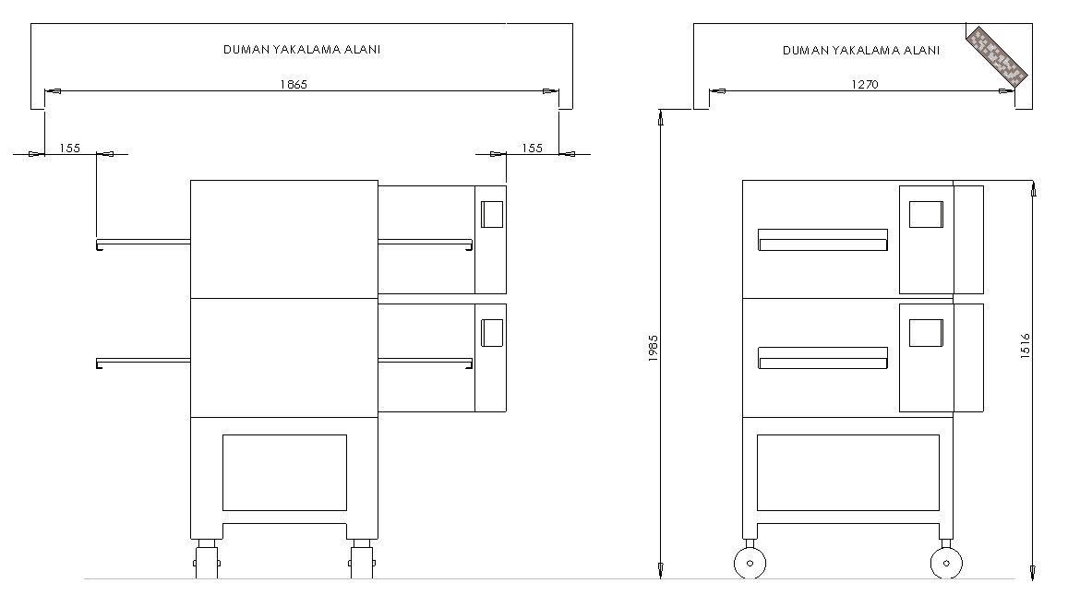
SMOKE CAPTURE AREA
SMOKE CAPTURE AREA

You are ready for services to be connected. This should be done by a qualified electrician, or installer of your choice.
DO NOT ATTEMPT TO OPERATE THE OVEN until connection of utility service and installation has been fully inspected (START-UP CHECKOUT) by and Authorized Service Technician.
This is important service, In order to assure the oven(s) is/are properly installed and in working order. The warranty becomes effective upon verification of proper installation. The warranty shall not apply if the oven(s) is/are started up and operated prior to the “START-UP CHECKOUT” being performed by an Authorized Service Technician.
DANGER! Do not work around conveyor belt with long hair, loose clothing, or dangling
jewelry. Getting caught in the belt could result in serious injury.
DANGER! If the power supply cord appears to be damaged, do not attempt to operate
the unit. Contact a service agent or qualified electrician to repair!

3.4 Installation Elements:
1 x 10 A (K AUTOMAT) – Fuse
Cable section: 1, 5 mm² (TTR Cable – 1 Faze / 1 Neutral / 1 Ground)
NOTE: TTR Cable is Flexible, shatterproof and loosen proof.
Grounding has to be proper.
Use regulator if voltage is high or low.
NOTE: If you fallow the above steps, assembly process can be made smoothly and quickly.

3.5 SEN 1500 Oven Technical Specifications Table:
Oven Electricity Technical Specifications Table
Voltage | Faze | N | T (PE) | Cable Minimum Section | kW | Ampere Load
 |  |  |  |  |  | L1 | L2 | L3
400V 50/60HZ | 3 | 1 | 1 | 2,5 mm² | 10 kw | 14 | 14 | 15,5

SEN 1500 3 FAZE CONNECTION
1

R
4

2
S
5

3
T
6

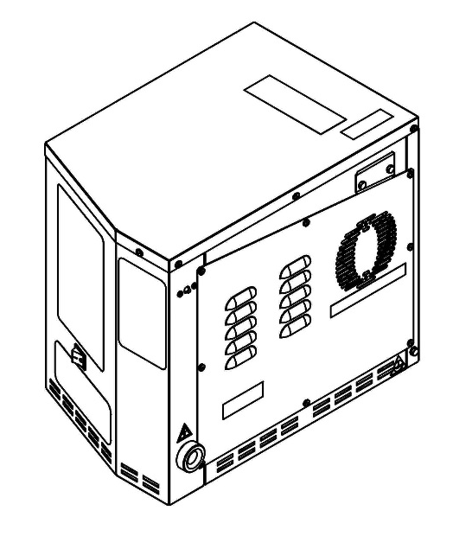
R
1
2
3
4
5
S
T
Terminal
Blog
N
PE

FUSE
POWER CABLE ENTRANCE
POTENTIAL GROUNDING

SECTION 4: PROGRAMMING, OPERATING AND CLOSING
All functions of the oven are controlled by the microprocessor. The oven must be pre-programmed for operation. The following pages are described step by in programming.
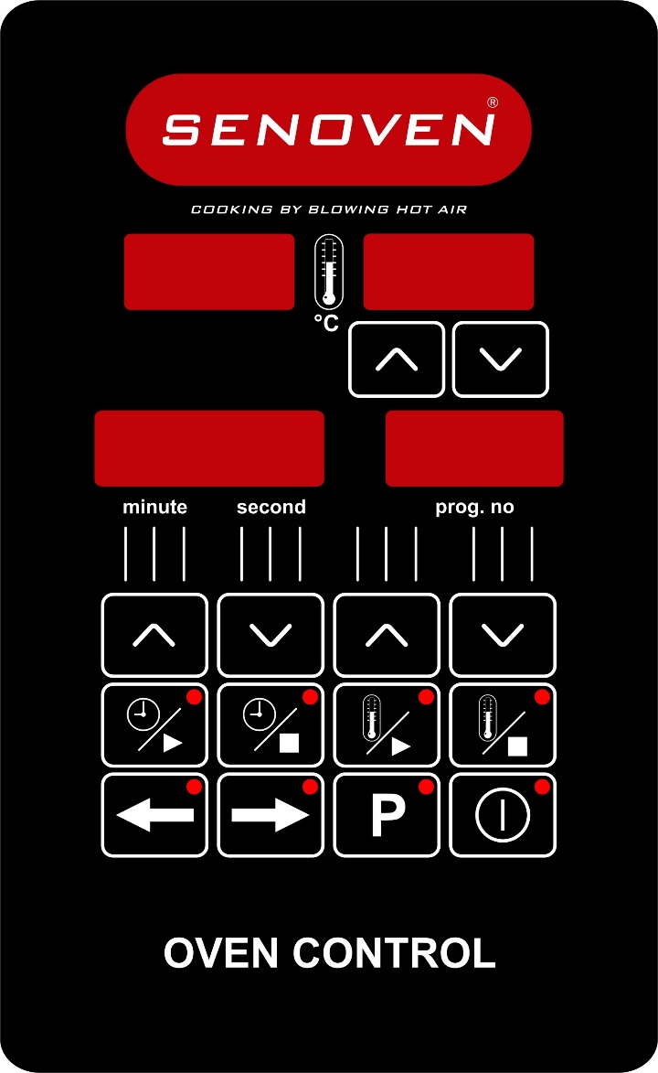
OVEN CONTROL DEVICE

Working Condition

Working Temperature: -20 - 70°C

Maximum Damp: %90 Rh (without condensation)

Height: Up to 2000 meters
Environments where device use is not suitable.
Corrosive atmospheric environments.
Explosive atmospheric environments.
Home applications. (The device only can be used industrial applications.)

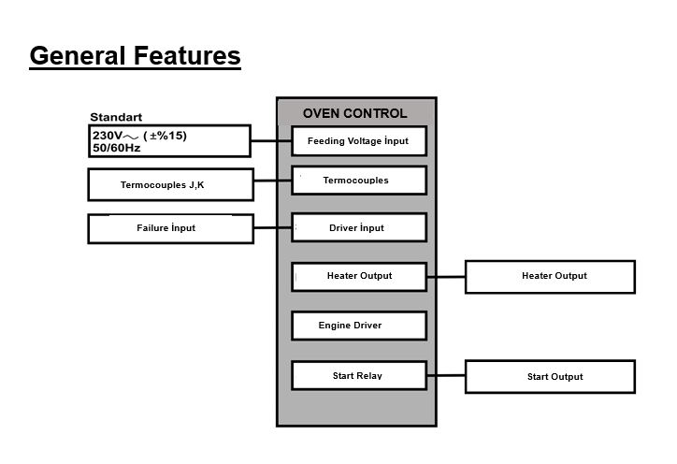
General Features

Electrical Connection Shema
Feeding Voltage İnput
OVEN CONTROL
Termocouples iiinputİnput
Termocouples J,K
Driver Fault
Failure İnput
Heater Output
Engine Driver Outlet
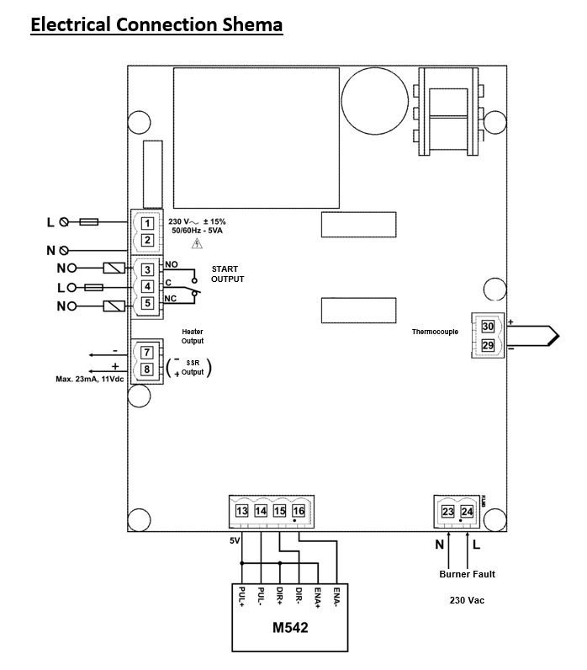

START OUTPUT
Burner Fault
230 Vac
(For Gaseous Model)
Thermocouple
İnput
Heater Output
SSR Output
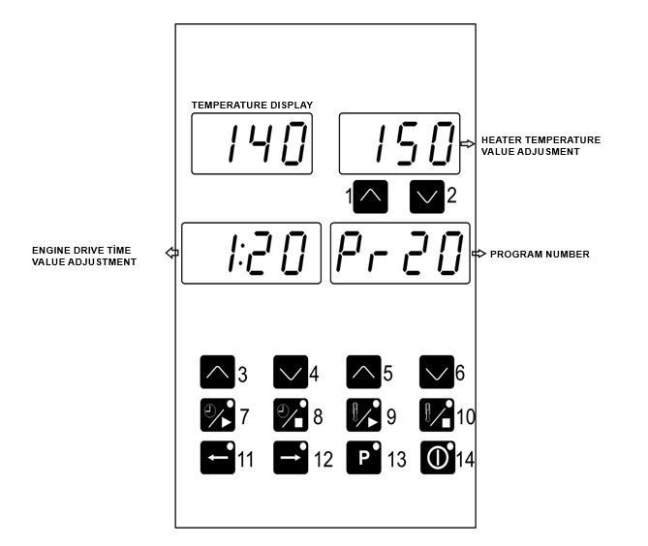
Oven Control Device Front Panel Definition

TEMPERATURE DISPLAY

ENGINE DRIVE TİME VALUE ADJUSTMENT
1 - 2. Temperature Set Increase and Decrease Buttons: With these buttons, the temperature set valves of program number that appear on the upper display are changed.
3 - 4. Engıne Driver Time Increase and Decrease Buttons: Set the time in minutes and seconds with these buttons.
5 - 6. Program Increase and Decrease Buttons: The desired program number is selected using these buttons.
7. Engine Start Button: Press this button to start the engıne.
8. Engine Stop Button: Press this button to stop the engıne.
9. Heater Start Button: Press this button to activate the heater output is active.
10. Heater Stop Button: This button stops the output when heater output is active.
11. Belt Back Button: Rotates the engıne counterclockwise when this button is pressed.
12. Belt Forded Button: Rotates the engine clockwise when this button is pressed.
13. Program Set Button: Press this button once for 5 seconds and enter the set section.
14. ON/OFF Button: With this button the device is returned to the “on’’ or “off’’ state . Button turns off when the device is switched off screen turns off.

Changing Program Values and Record
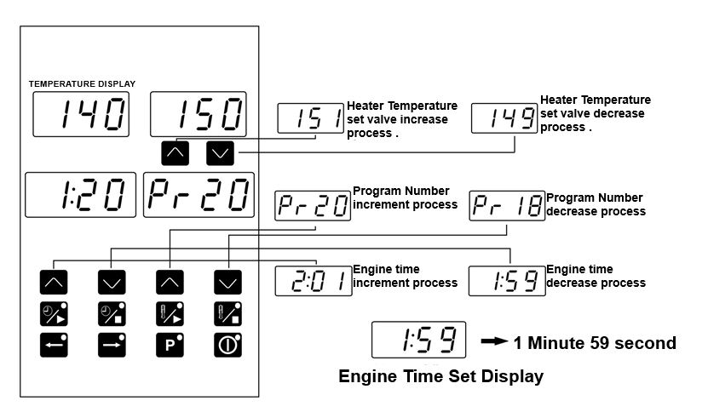

Heater Temperature set valve increase process .
TEMPERATURE DISPLAY
Engine time increment process
Engine Time Set Display
Program Number increment process

The values of that program appear on the screens after the program number has been entered. Set values are changed with the help of boost and decrease buttons. Press ‘P’ button for 5 seconds to enter the set section. In this case the changed set values are recorded. The set values that are modified are instantaneous values. These values are not saved to the program. The old values of the program are displayed again when switching to the off position or when the power is turned off.

Programs are only saved when the heater is in the stop position. The set values changed in the start position are instantaneous values. These values are not saved to the program. The old values of the program are displayed again when switching to the stop position.

4.1 Warnings:
1. If product not cooking, check cooking times and heat set.
2. If the product over cooked, check cooking times and heat set. Conveyor can be slowly.
3. If all values are normal but the product still doesn’t cook or over heat, call the manufacturer.

4.2 Closing
Top the switch off the oven. The attention, you can turn off the switch on the display will appear .And then you can turn off switch.

4.3 Functions:
4.3.1 Temperature Cutting Switch:
Our oven has a temperature cut. Off switch for you safety and protection. This switch is specially designed to prevent the oven from overheating and causing damage in a small possibility, if the operating temperature of the furnace increases and the power is prevented from being transferred to the furnace. No parts are damaged due to excessive temperature.
WARNING! Do not use an external switch to do not block to the temperature switch.

4.3.2 Electrical Installations:
WARNING! Grounding must be done properly before install of the oven. Electrical damage causes fatal injuries or death.
For All Foreign Countries:
Apply local electrical rules.
- All Poles connect switches have 3mm wide.

- Grounding cable head is back on the oven.

- If you use more than one oven (double or triple) each oven must has its own switch and all switches should be close together.

4.3.3 Operator Maintenance:

WARNING! Disconnect power supply before servicing or cleaning this oven Safeguard power so it cannot be accidentally restored. Failure to do so could result in dismemberment, electrocution, or fatal injury. There is more than one power supply connection point when ovens are stacked. Make sure that all switches are in the “OFF” position before cleaning or maintenance.
To maintain maximum efficiency of the oven, it is necessary to keep it clean, all ventilation louvers on the oven must be cleaned regularly. Oven use and type of product will actually determine the frequency of cleaning. The conveyor drive chain should be checked during the weekly cleaning cycle to see if it has become loose. Loose chain operation will DAMAGE the conveyor drive motor.
If the oven fails to operate, check the circuit breaker to be sure it is turned on. Be sure that circuit breaker is ok before you call the Authorized Service Agency. The name and phone number of the Authorized Service Agency should be located at the bottom of the data plate.

4.3.4 Cleaning Instructions:
The oven contains electrical components. Before cleaning the oven, switch off and disconnect the oven from the electrical supply.
No electrical components should be subjected to moisture. It is, therefore, important that the oven is wiped down carefully. NEVER throw buckets of water over the oven or subject it to pressure washing from a hose or a pressure spray. If water or other liquid is spilled on the oven, make sure that none has entered the control box area before switching on. If in doubt, call your service company.
WARNING! Oven must be cool. Do not use power-cleaning equipment, steel wool, or wire brushes on stainless steel surfaces.
DAILY;
- Clean the outer surfaces with a mild detergent cloth. You can also use a commercial stainless steel cleaner product. Then clean the detergent residue with a wet cloth.
- Wash the preservatives of the front and rear waste collection plates with a mild detergent and rinse with water.
- Wash the outlet sheet with a mild detergent and rinse with water.
- Wash the stoppers with a mild detergent and rinse with water.
- Clean the loose particles inside, then wipe them with a mild detergent, and clean the detergent residue with a wet cloth.
- Clean the conveyor with a clean cloth or with a soft wire brush.

On exterior of oven, deposits of baked-on splatter, oil, grease, or light discoloration may be removed with any of several commercial cleaners. Consult with your local supplier.

MONTHLY;
- Remove, disassemble and clean air vents. Refer to "Air Duct Removal” for more information.
- Remove the tape, dismantle and clean it. See “tape mounting and wire mounting” for more information.
- Remove, disassemble and clean the oven room front and rear covers.

NOTE: Make sure that the hood is cleaned according to the specifications of the ventilation equipment vendor.

4.3.5 Protective Maintenance:
Although this oven has been designed to be as trouble free as possible, periodic Preventive Maintenance is essential to maintain peak performance. It is necessary to keep the motors, fans, and electronic controls free of dirt, dust and debris to insure proper cooling. Overheating is detrimental to the life of all components mentioned.
The periodic intervals for preventative cleaning may vary greatly depending upon the environment in which the oven is operating.
You must discuss the need for Preventive Maintenance with your Authorized Service Company to establish a proper program.

4.3.6 How to Call Technical Service?
If the oven not working, see if automatic fuse works. If there is no problem call technical service. There is technical service number on the information plate on the back of the oven. If you can’t see technical service number on the oven, please call company.

SECTION 5: COOKED PRODUCTS
5.1 Some of The Cooked Products:
- Brownie
- Hamburger
- Hot Dogs
- Omelet
- Pancakes
- Mixed Vegetable Plate
- Steakhouse
- Skewers
- Meatball
- Potato
- Borek
- Chicken Wings
- Grilled Chicken

- Chicken Saute
- Bread
- Breakfast
- Fish
- Seafood
- Pizza
- Lavas
- Lahmacun
- Pita
- Kunefe
- Chocolate Cookie
- Pie
- Etc. Many Foods

SEN series ovens, show much better performance than other ovens (Especially pizza cooking).

5.2 Cooking Time and Temperature:

PİZZA
- 260 °C
- TIME: 6 MINUTES
- ALUMINIUM PAN
- FRESH

PİDE
- 260 °C
- TIME: 5 MINUTES
- OVER CONVEYOR
- FRESH

5.3 Total Cooking Calculation:

Pan Length
(A)
Sample 1:
Oven Chamber Length: 710 mm.
Cooking Time: 2 dk.
Pan Length: 250 mm.

250
1
2
3
2
1

Sample 2:
Oven Chamber Length: 710 mm.
Cooking Time: 5 dk.
Pan Length: 500 mm.

500

Pan Length
(B)

5.4 Sample Capacity Table:

SAMPLE CAPACITY TABLE
Dimeter Pizza | 3 Minutes | 3 ½ | 4 Minutes | 4 ½
30 cm | 55 | 47 | 41 | 37
36 cm | 40 | 34 | 30 | 27
41 cm | 35 | 30 | 26 | 23
Dimeter Pizza | 5 Minutes | 5 ½ | 6 Minutes | 6 ½
30 cm | 33 | 30 | 28 | 25
36 cm | 24 | 22 | 20 | 18
41 cm | 21 | 19 | 18 | 16
Dimeter Pizza | 7 Minutes | 7 ½ | 8 Minutes
30 cm | 24 | 22 | 21
36 cm | 17 | 16 | 15
41 cm | 15 | 14 | 13

SECTION 6: SPARE PARTS MANUAL

SPARE
PARTS
MANUAL

M00367 FRONT

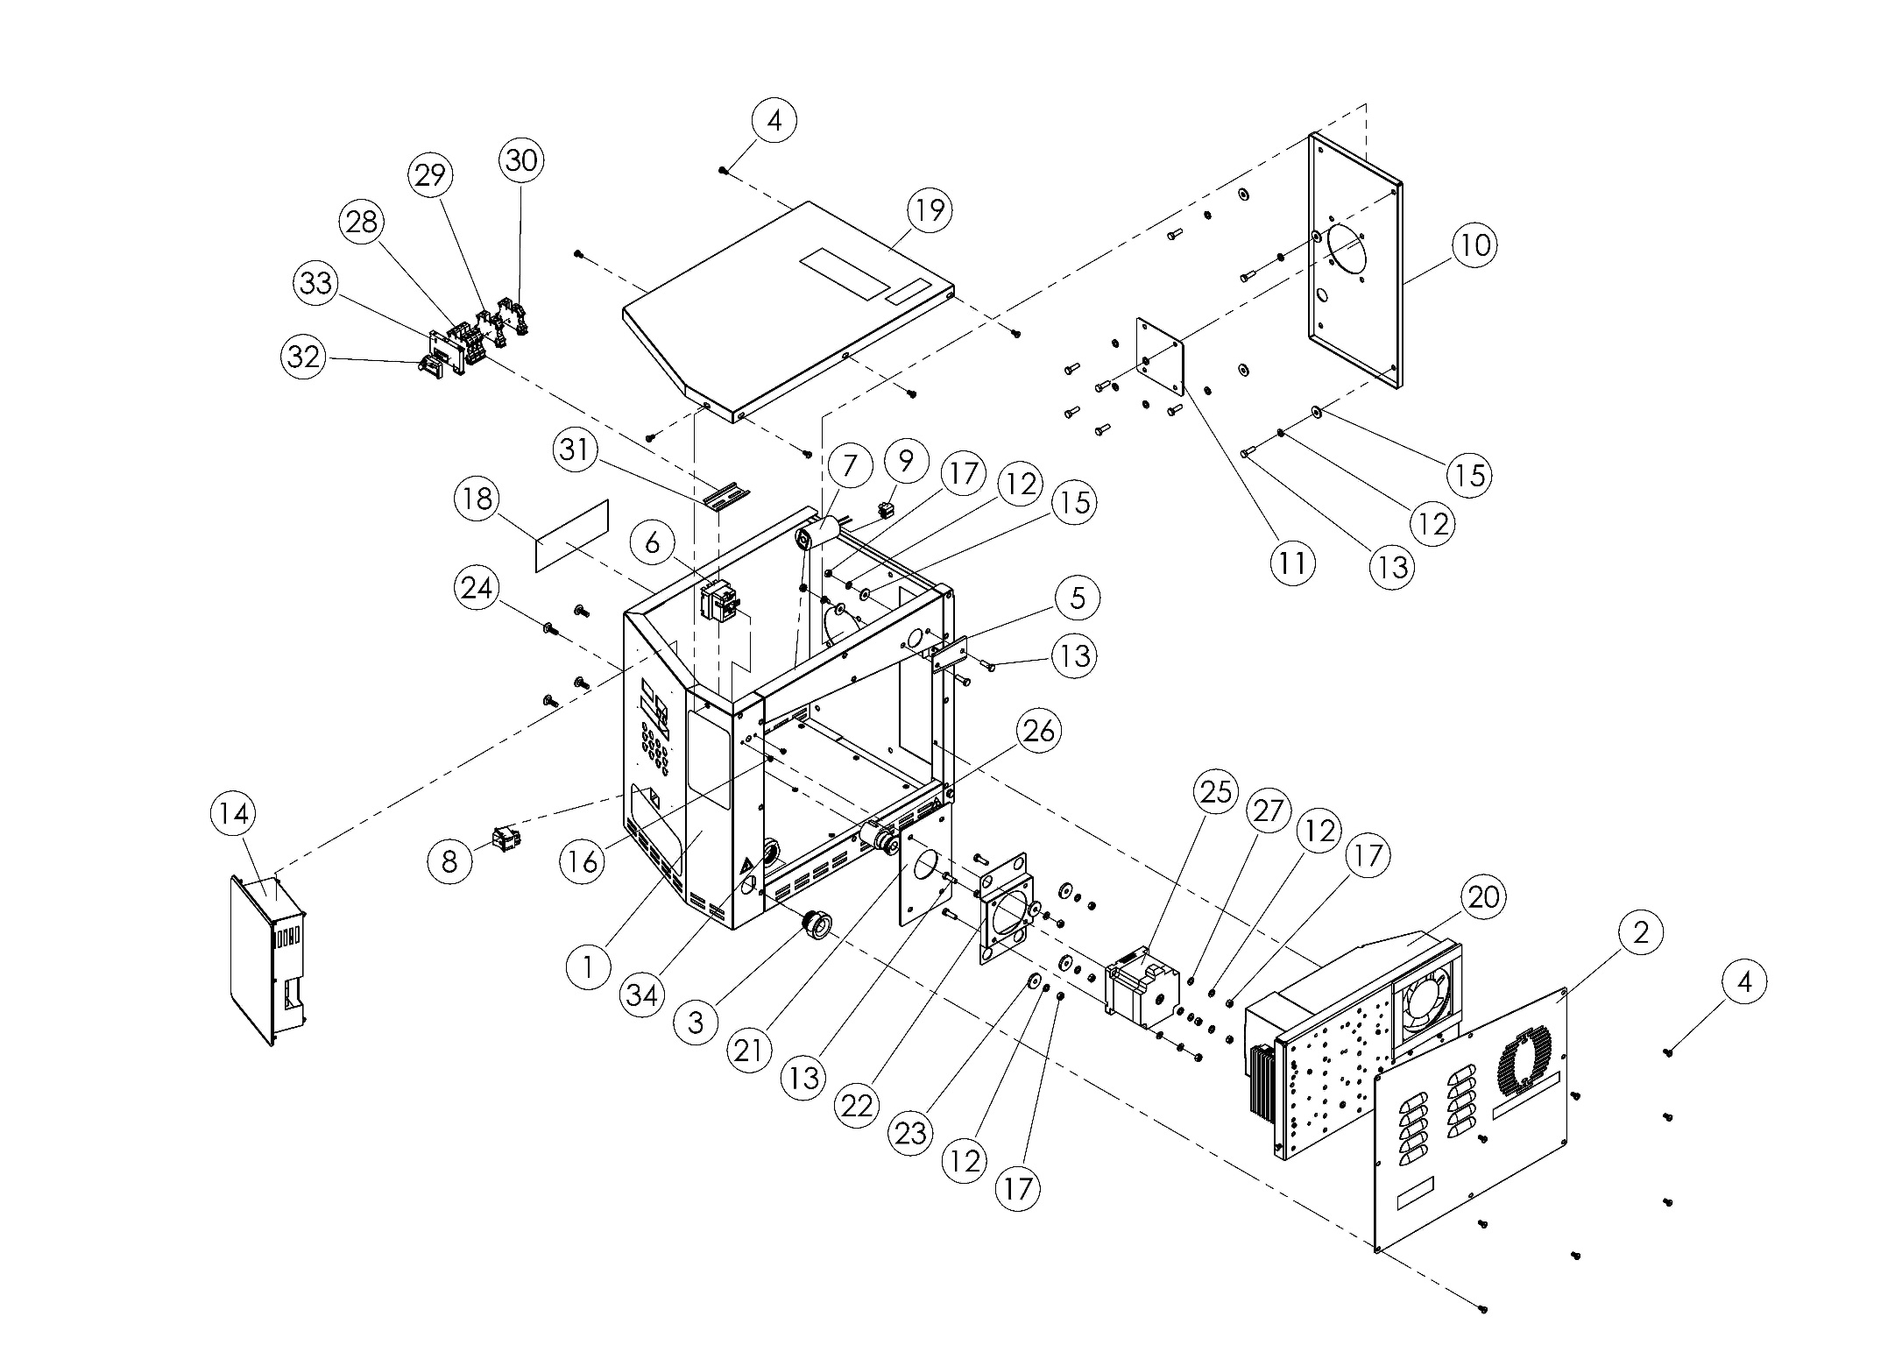

M00367 (FRONT) SPARE PARTS LIST
ITEM | SPARE PART NUMBER | SPARE PART DESCRIPTION | UNIT |  | ITEM | SPARE PART NUMBER | SPARE PART DESCRIPTION | UNIT
1 | 00365M | CONTROL BOX | 1 |  | 18 | 01875 | LABEL | 1
2 | 01510M | COVER SHEET | 1 |  | 19 | 01511M | CONTROL BOX COVER | 1
3 | 01184 | RECORD | 1 |  | 20 | M00372 | SSR BOX | 1
4 | 00046 | BOLT | 15 |  | 21 | 01861 | ENGINE SHEET | 1
5 | 02203 | COVER SHEET | 1 |  | 22 | 01862 | STEP ENGINE SHEET | 1
6 | 01815 | LIMIT THERMOSTAT | 1 |  | 23 | 00006 | WASHER | 4
7 | 02194 | CONDENSER | 1 |  | 24 | 01867 | BOLT | 4
8 | 08091 | BUTTON | 1 |  | 25 | 01850 | ENGINE | 1
9 | 00061 | TERMINAL | 1 |  | 26 | 01515M | ENGINE MOUTING ROD | 1
10 | 01625 | SUPPORT SHEET | 1 |  | 27 | 00317 | WASHER | 4
11 | 01744 | BURNER SHEET | 1 |  | 28 | 02211 | TERMINAL BEIGE | 3
12 | 00042 | WASHER | 19 |  | 29 | 02210 | TERMINAL BLUE | 1
13 | 00041 | BOLT | 15 |  | 30 | 02209 | TERMINAL | 1
14 | 00316M | SCREEN | 1 |  | 31 | 01348 | TERMINAL RAIL | 1
15 | 02579 | WASHER | 6 |  | 32 | 00292 | LIMITER | 1
16 | 01831 | BOLT | 2 |  | 33 | 01865 | GLASS BRAKER TERMINALS | 1
17 | 01305 | NUT | 10 |  | 34 | 01089 | RECORD NUT | 1

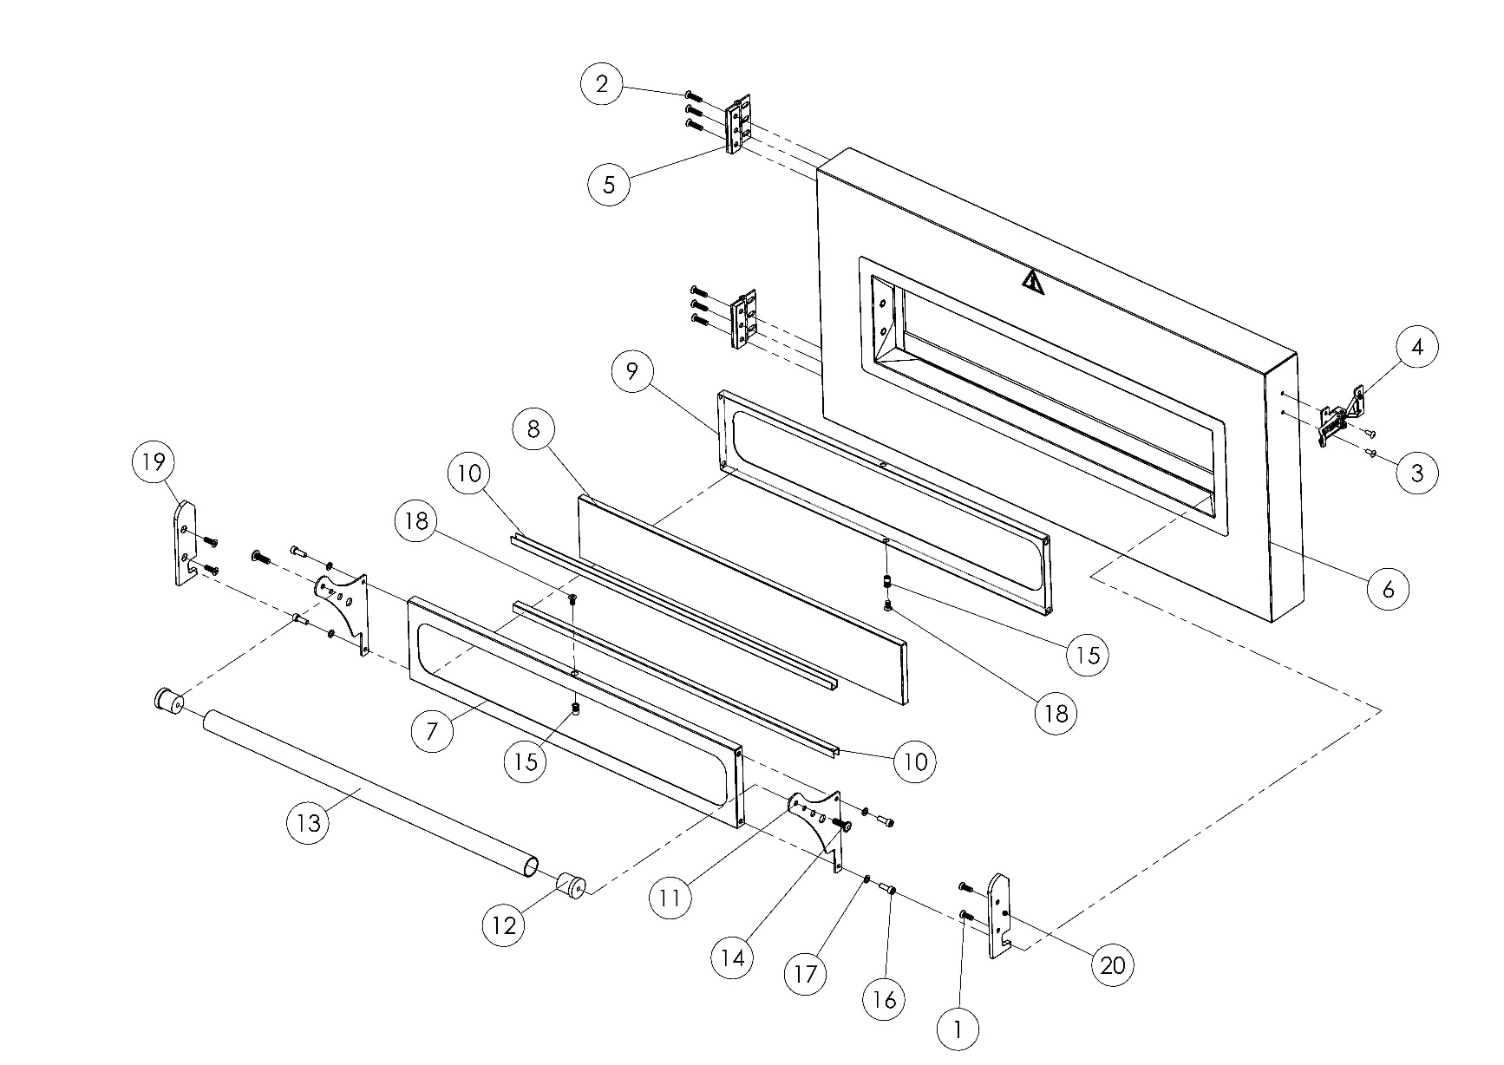
M00321 FRONT COVER

M00321 (FRONT COVER) SPARE PARTS LIST
ITEM | SPARE PARTS NUMBER | SPARE PARTS DESCRIPTION | UNIT
1 | 01558 | BOLT | 4
2 | 01530 | BOLT | 6
3 | 01529 | RIVET | 2
4 | 01528 | HOOD LOCK | 1
5 | 01067M | HINGE | 2
6 | 01068M | COVER | 1
7 | 07161 | GLASS FRAME | 1
8 | 01548 | WINDOW | 1
9 | 07162 | GLASS FRAME | 1
10 | 07160 | GLASS FRAME BRACKET | 2
11 | 01759 | GLASS EDGE SHEET | 2
12 | 01752-1 | RUBBER PLUG | 2
13 | 01753-1 | COVER HANDLE | 1
14 | 02342 | BOLT | 2
15 | 00045 | FIX | 6
16 | 101503 | BOLT | 4
17 | 04077 | WASHER | 4
18 | 00157 | BOLT | 2
19 | 07172 | GLASS ON/OFF LAMA | 1
20 | 07170 | GLASS ON/OFF LAMA | 1

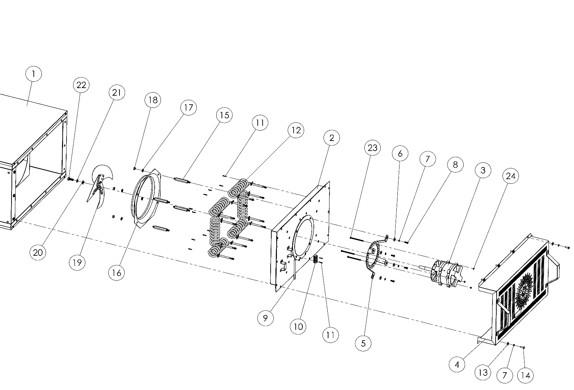
M00405 BACK COVER
(TYPE-1)

M00405 BACK COVER (TYPE-1) SPARE PARTS LIST
ITEM | SPARE PARTS NUMBER | SPARE PARTS DESCRIPTION | UNIT
1 | M00269 | BODY | 1
2 | 00454M | BACK ISOLATION PACKAGE | 1
3 | 101509 | F.I.R ENGINE | 1
4 | 01075M | BACK COVER | 1
5 | 01984 | ENGINE SHEET | 1
6 | 02579 | WASHER | 4
7 | 00042 | WASHER | 18
8 | 04082 | BOLT | 4
9 | 01317 | RESISTANCE OUTPUT MACARON | 1
10 | 01728 | TERMINAL | 1
11 | 01672 | BOLT | 14
12 | 01600 | RESISTANCE | 6
13 | 01299 | WASHER | 14
14 | 00041 | BOLT | 14
15 | 01717 | STUD | 4
16 | 01718 | FAN CASING SHEET | 1
17 | 01961 | WASHER | 4
18 | 01959 | NUT | 4
19 | 01078M | FAN | 1
20 | 00277 | WASHER | 1
21 | 01960 | WASHER | 1
22 | 00279 | BOLT | 1
23 | 02391 | BOLT | 3
24 | 00052 | NUT | 3

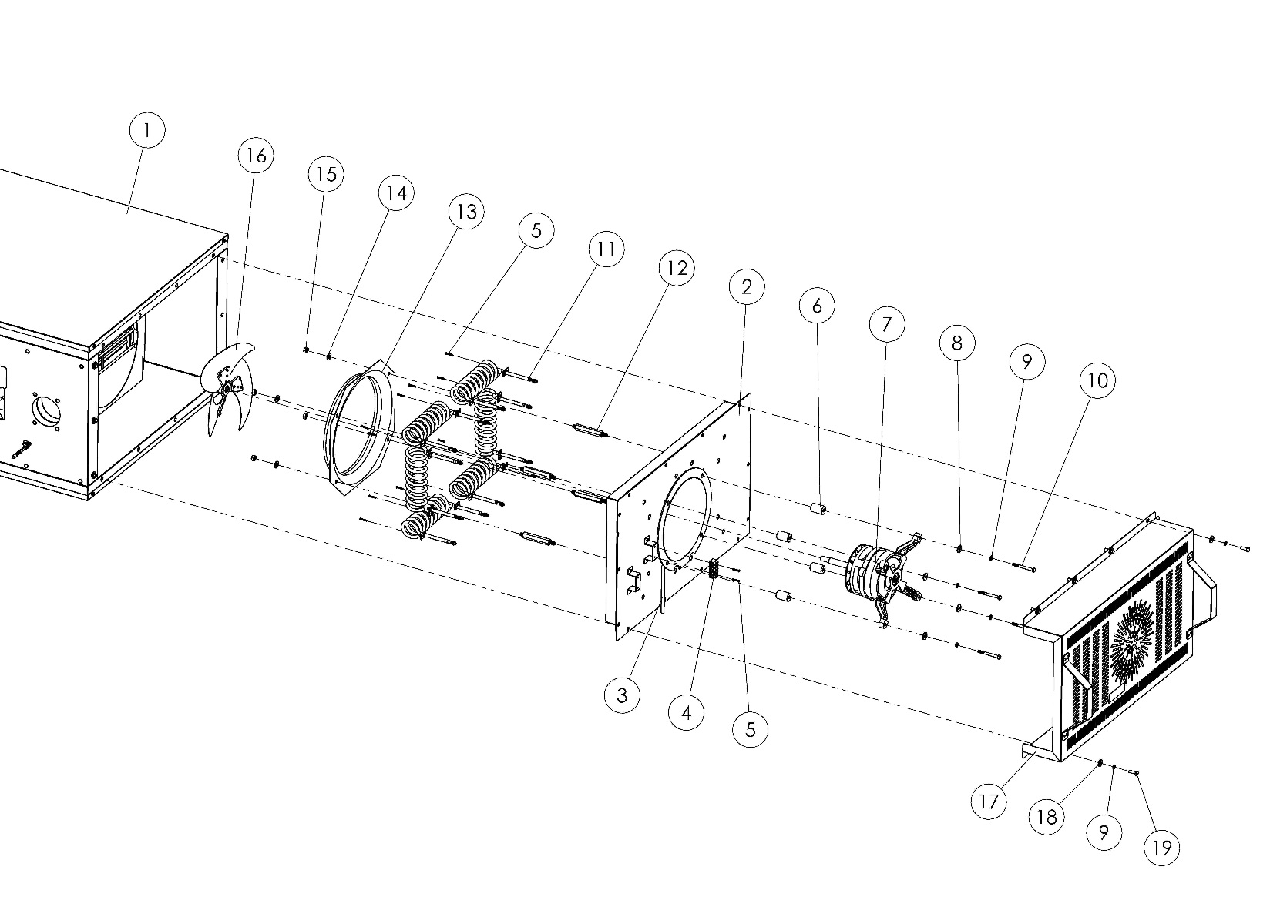
M00404 BACK COVER
(TYPE-2)

M00404 BACK COVER (TYPE-2) SPARE PARTS LIST
ITEM | SPARE PARTS NUMBER | SPARE PARTS DESCRIPTION | UNIT
1 | M00269 | BODY | 1
2 | 00454M | BACK ISOLATION PACKAGE | 1
3 | 01317 | RESISTANCE OUTPUT MACARON | 1
4 | 01728 | TERMINALS | 1
5 | 01672 | BOLT | 14
6 | 01722 | WEDGE | 4
7 | 01719 | BAHÇIVAN ENGINE | 1
8 | 02579 | WASHER | 4
9 | 00042 | WASHER | 18
10 | 01519 | BOLT | 4
11 | 01600 | RESISTANCE | 6
12 | 01717 | STUD | 4
13 | 01718 | FAN CASING SHEET | 1
14 | 01961 | WASHER | 4
15 | 01959 | NUT | 4
16 | 00426M | FAN | 1
17 | 01075M | BACK COVER | 1
18 | 01299 | WASHER | 14
19 | 00041 | BOLT | 14

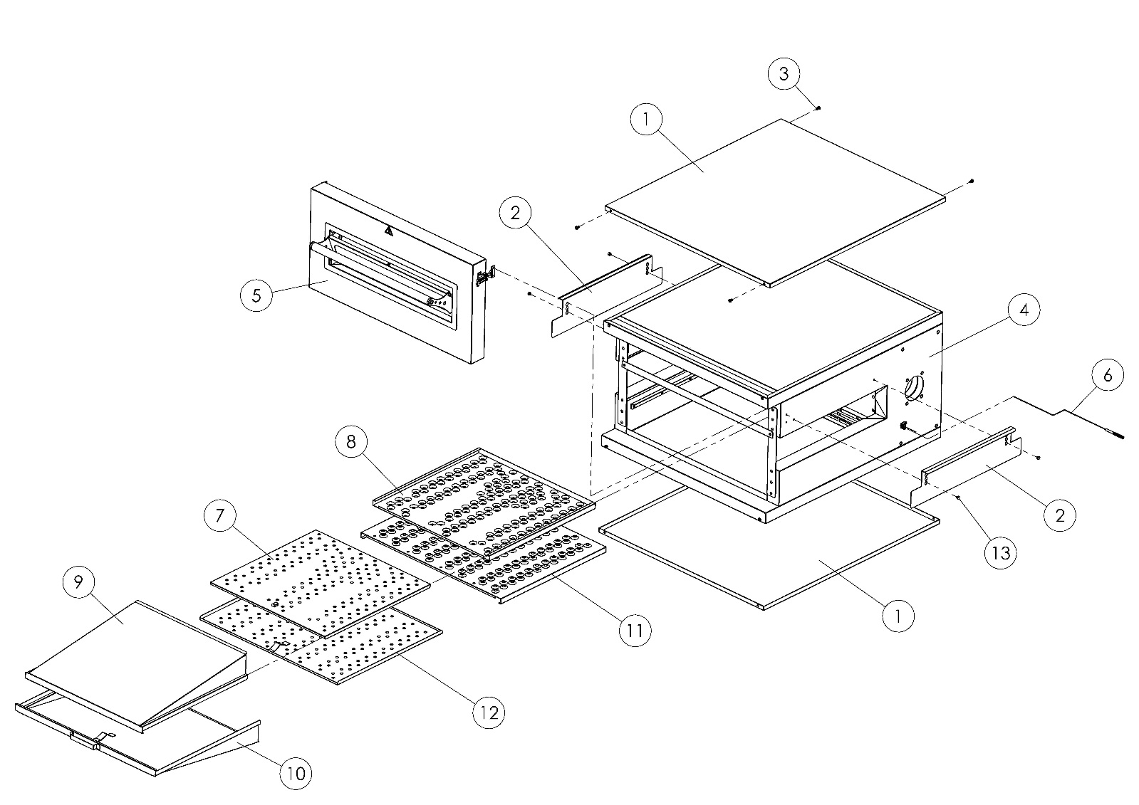
M00269 BODY

M00269 (BODY) SPARE PARTS LIST
ITEM | SPARE PARTS NUMBER | SPARE PARTS DESCRIPTION | UNIT
1 | 01562 | ISOLATION PACKAGE | 2
2 | 01572-1 | INPUT/OUTPUT SHEET | 2
3 | 00046 | BOLT | 8
4 | 01081M | OVEN BODY | 1
5 | M00321 | FRONT COVER | 1
6 | 01731 | THERMOCOUPLES | 1
7 | 01070M | AIR DISTRIBUTOR SHEET | 1
8 | 01630 | SMALL FINGER PLASTER SHEET | 1
9 | 01073M | SMALL AIRWAYS SHEET | 1
10 | 01072M | BIG AIRWAYS SHEET | 1
11 | 01631 | BIG FINGER PLASTER SHEET | 1
12 | 01071M | AIR MOUNTING SHEET | 1
13 | 01596-1 | PIN | 4

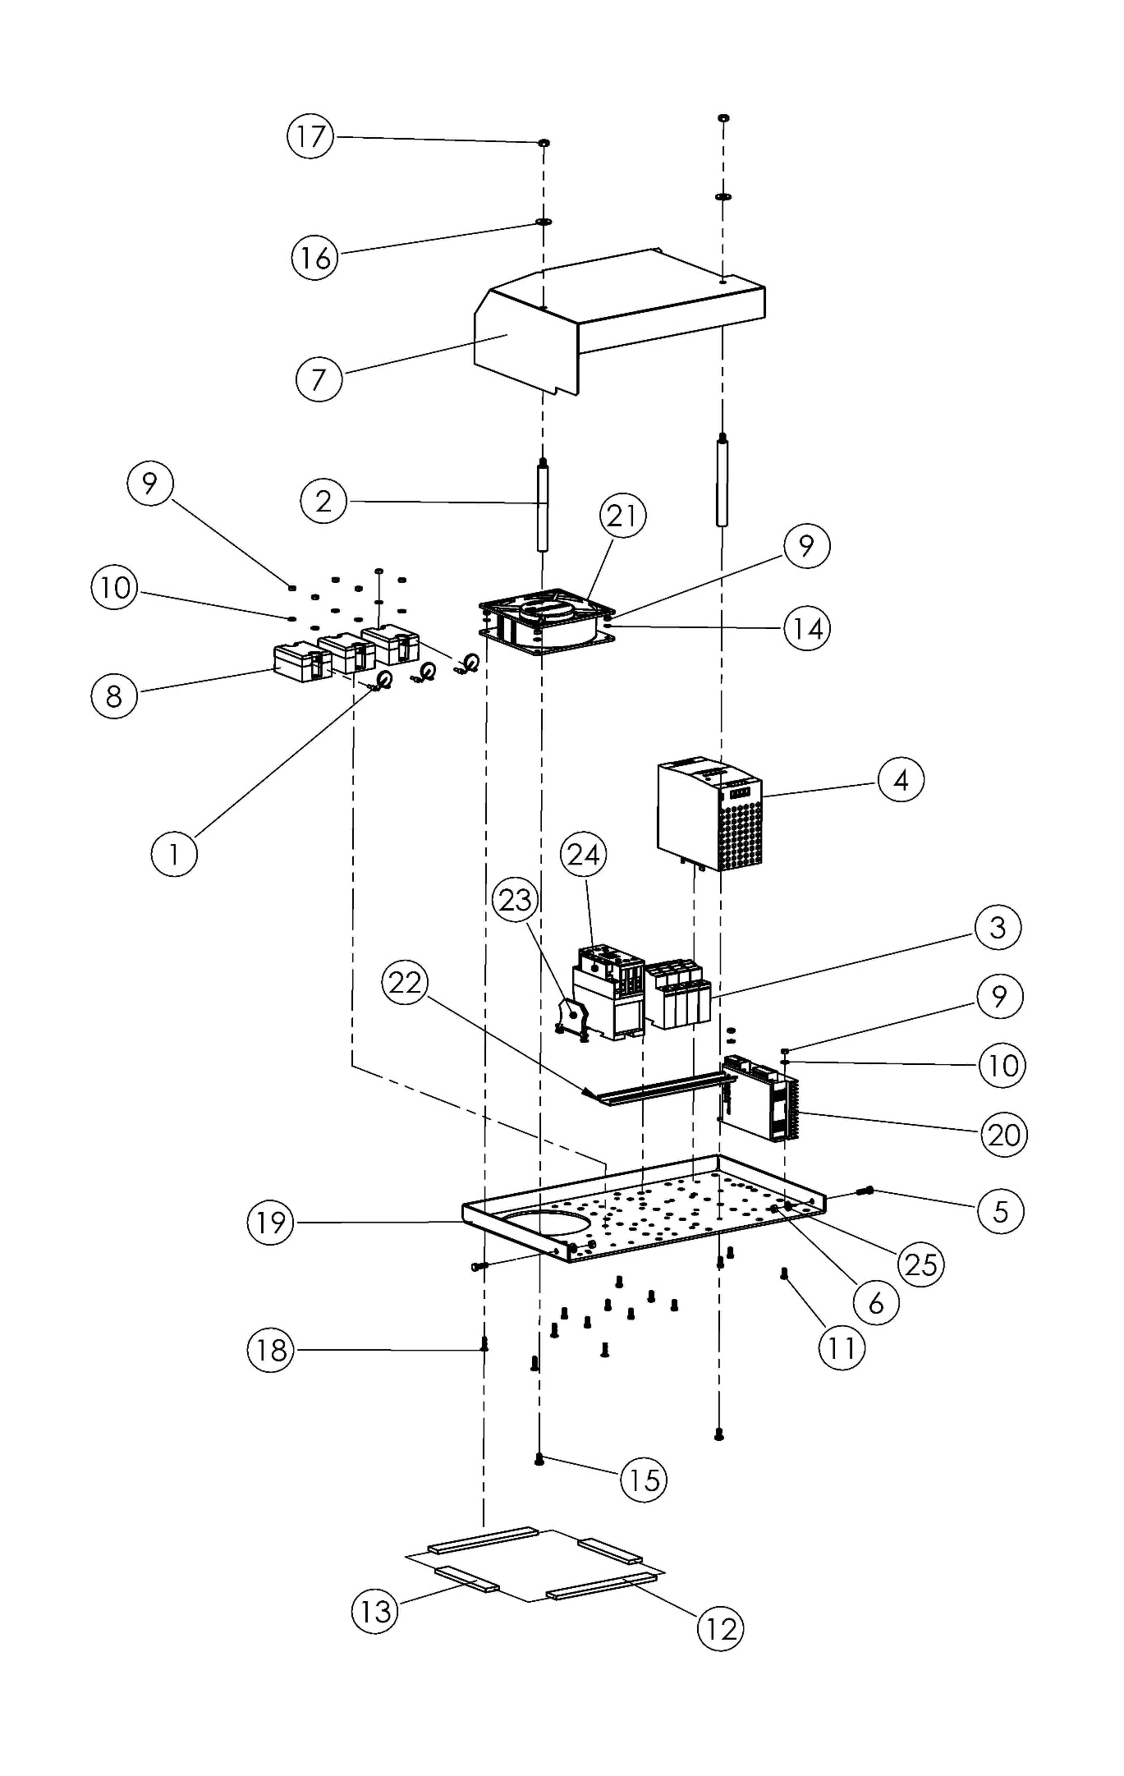
M00372 SSR BOX

M00372 (SSR BOX) SPARE PARTS LIST
ITEM NO. | SPARE PARTS NUMBER | SPARE PARTS DESCRIPTION | UNIT
1 | 01292 | VARISTOR | 3
2 | 01237 | STUD | 2
3 | 02189 | FUSE | 4
4 | 02319 | POWER SUPPLY | 1
5 | 00049 | BOLT | 2
6 | 00052 | NUT | 2
7 | 00367M | SSR SHEET | 1
8 | 01822 | SSR RELAY | 3
9 | 02634 | NUT | 12
10 | 01296 | WASHER | 8
11 | 01295 | BOLT | 10
12 | 01307 | SPONGE | 2
13 | 01306 | SPONGE | 2
14 | 01706 | WASHER | 4
15 | 00278 | BOLT | 2
16 | 01299 | WASHER | 2
17 | 01305 | NUT | 2
18 | 01271 | BOLT | 4
19 | 01011 | SSR SHEET | 1
20 | 02320 | SPEED CONTROL | 1
21 | 01290 | FAN | 1
22 | 01871 | TERMINAL RAIL | 1
23 | 01294 | TERMINAL (GROUNDING) | 1
24 | 01615 | CONDACTOR | 1
25 | 00051 | WASHER | 2

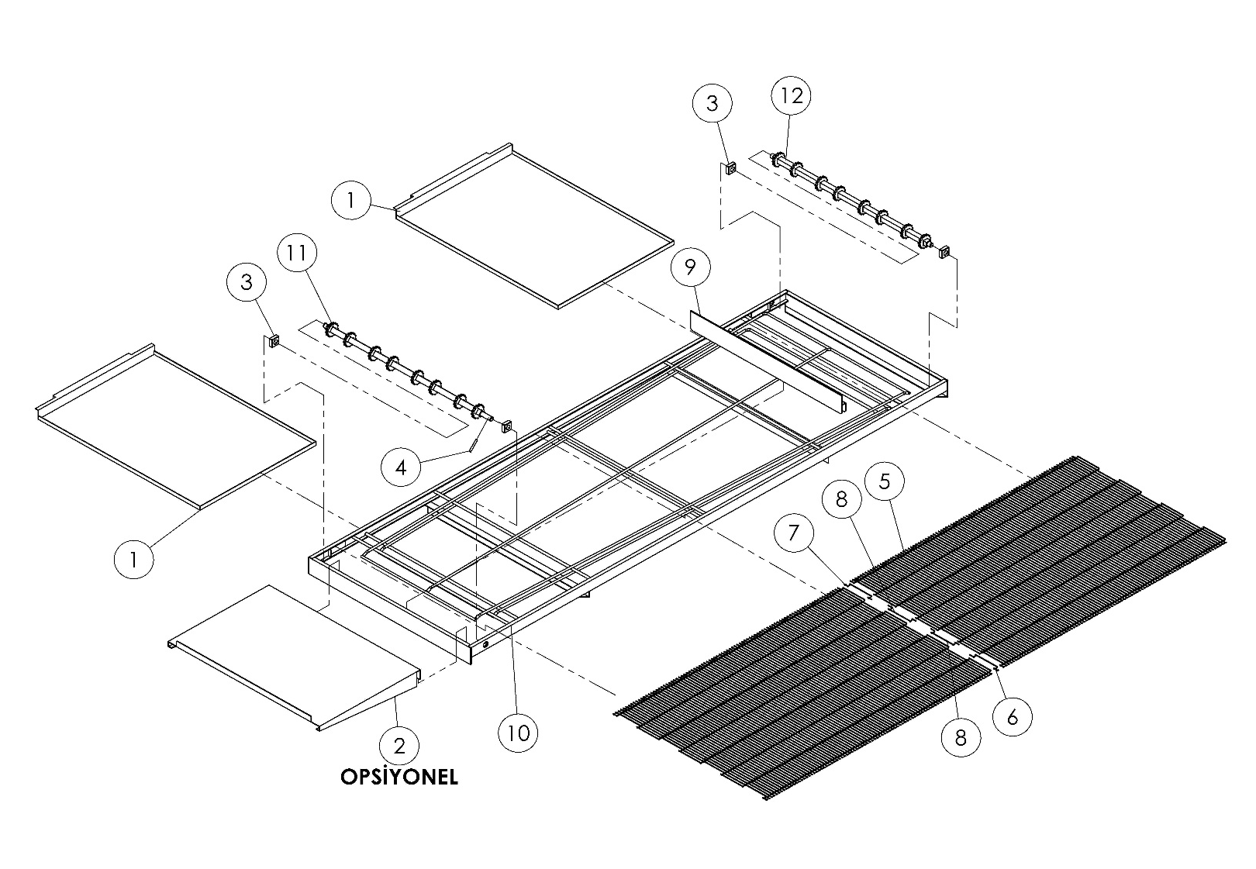
M00271 BELT

OPTIONAL

M00271 (BELT) SPARE PARTS LIST
ITEM NO: | SPARE PARTS NUMBER | SPARE PARTS DESCRIPTION | UNIT
1 | 01504 | WASTE PAN | 2
2 | 01520 | PRODUCT OUT SHEET (OPTIONAL) | 1
3 | 01516 | CONVEYOR DRIVE BEARING | 4
4 | 00096 | PIN | 1
5 | 01739M | BELT | 1
6 | 01736 | BELT RIGHT LOCK WIRE | 1
7 | 01737 | BELT LEFT LOCK WIRE | 1
8 | 01738 | BELT LOCK MIDDLE WIRE | 2
9 | 01505 | LIMITER CHASIS | 1
10 | 00325M | BELT CHASIS | 1
11 | 00323M | CONVEYOR DRIVE SHAFT | 1
12 | 00324M | CONVEYOR IDLE SHAFT | 1

SECTION 7: ELECTRICAL DIAGRAM

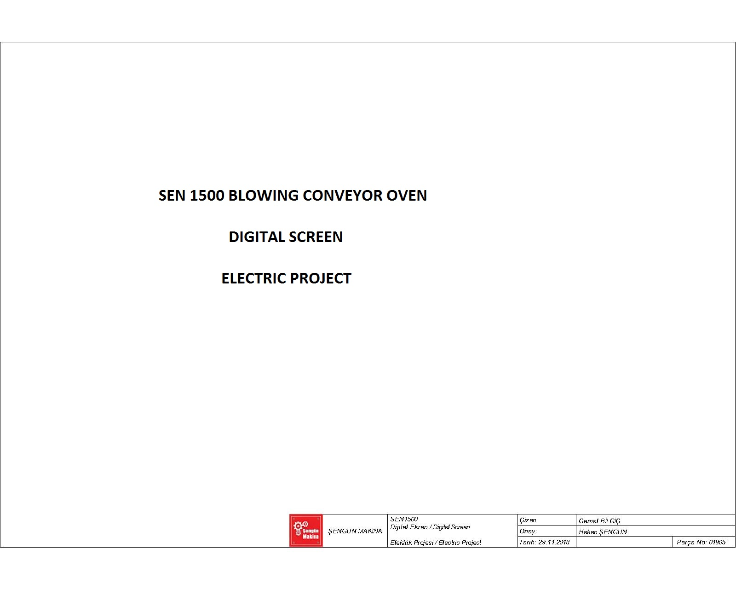

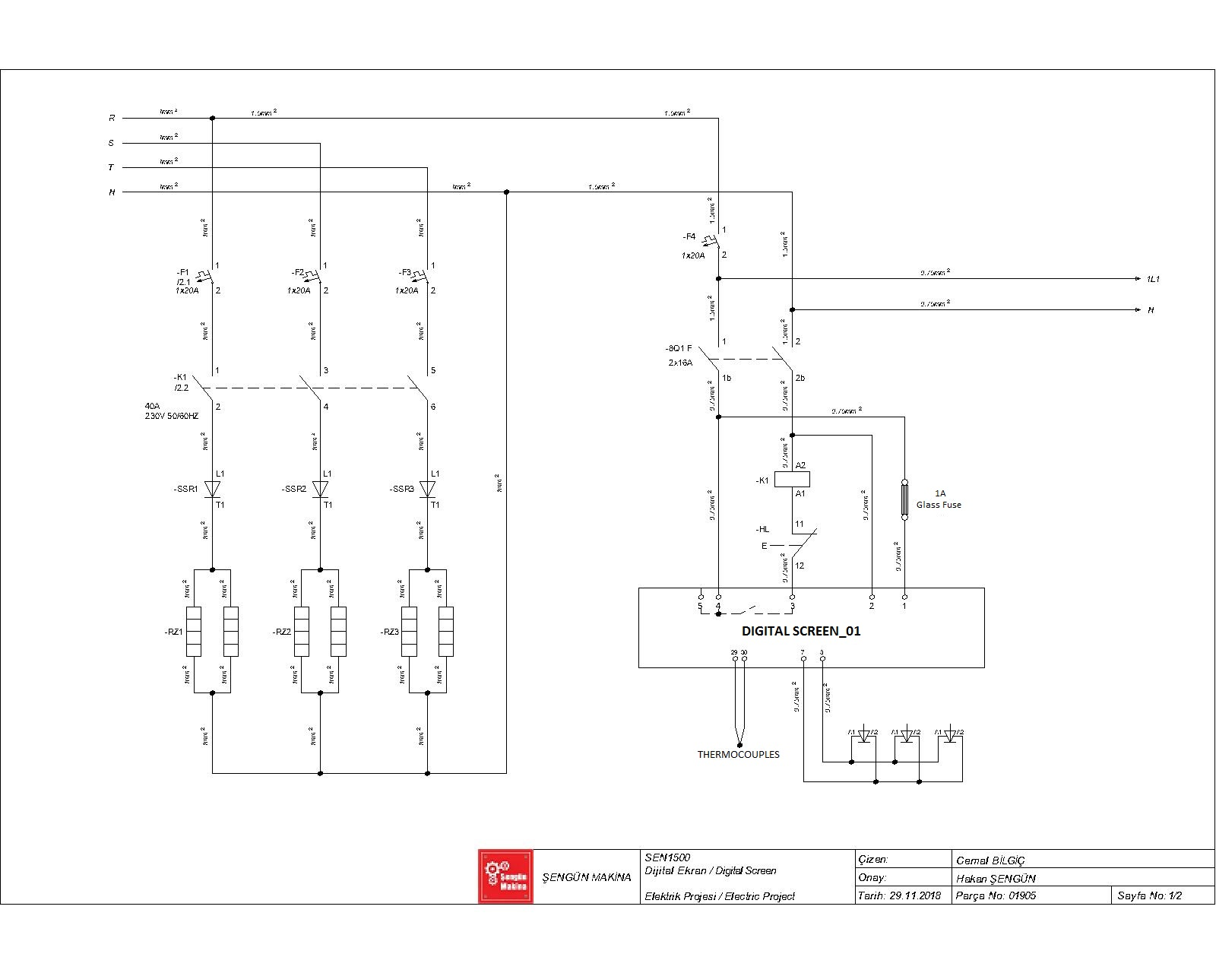

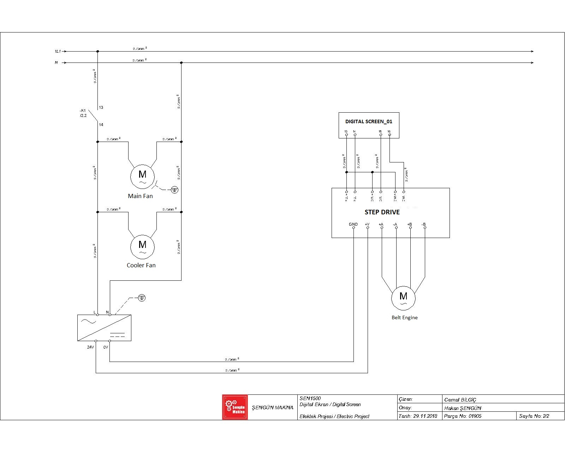

SECTION 8: LABELS


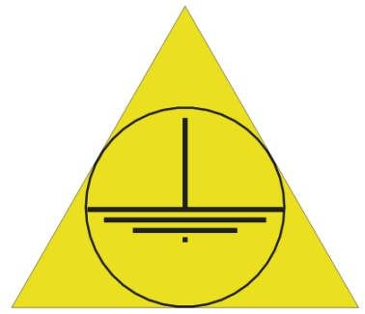
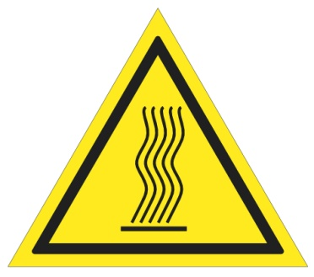

(High Temperature) (Grounding)
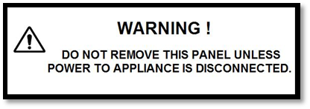


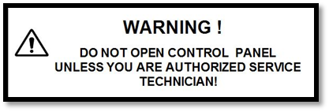

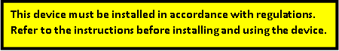

Electrical Input
Warning Labels

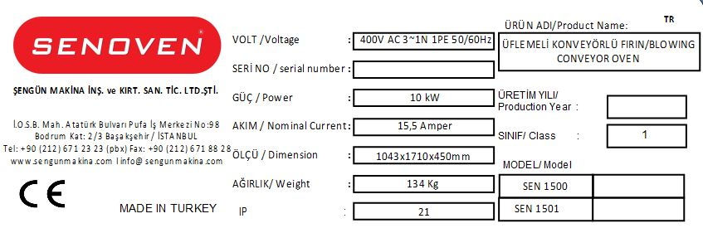

Technical Label (Product Card)

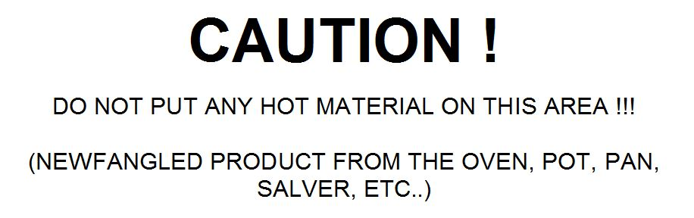

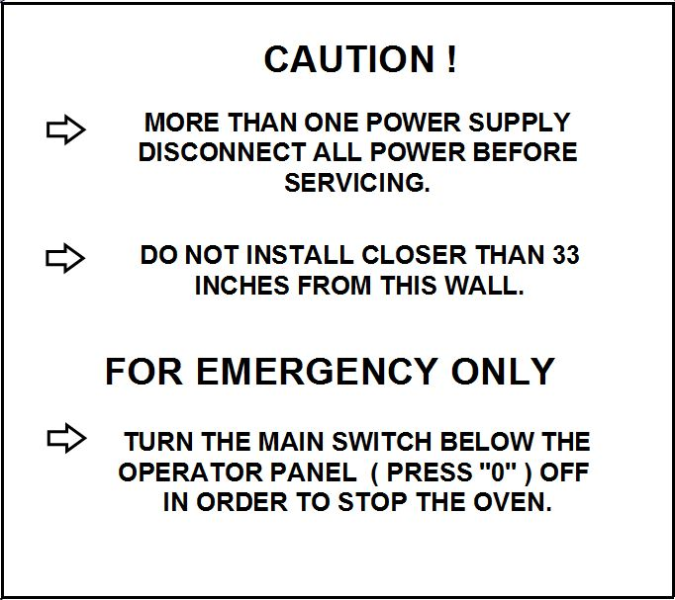

Warning Label

NOTE:



ŞENGÜN MAKİNA İNŞAAT VE KIRTASİYE SAN. TİC. LTD. ŞTİ.
İkitelli Organize Sanayi Bölgesi, Atatürk Bulvarı, Pufa İş Merkezi No: 98 Bodrum Kat: 2-3
Başakşehir/ İstanbul/ Türkiye

Phone: +90 212 671 23 23 (Pbx)
Phone 2: +90 212 671 84 84
Fax: +90 212 671 88 28
GSM: +90 533 957 14 53

e-Mail : info@sengunmakina.com
web : www.sengunmakina.com

