MODEL
SM-30, SM-40
DOUGH ROLLING MACHINE
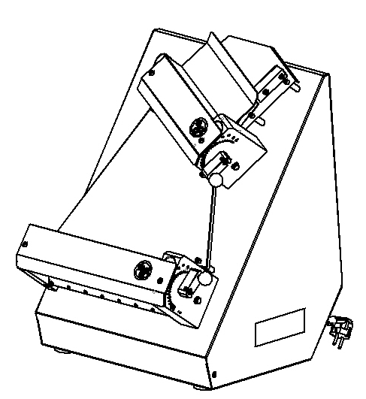

USER & MAINTENANCE MANUAL

ŞENGÜN MAKİNA İNŞAAT ve KIRTASİYE SAN. TİC. LTD. ŞTİ

WARRANTY CERTIFICATE
SERIAL NUMBER:
SALE DATE:
Sold at the above date SM- ……. MODEL DOUGHS ROLL OUT MACHINE is guaranteed against production failures for 1 Year by ŞENGÜN MAKİNA İNŞAAT ve KIRTASİYE SAN. TİC. LTD. ŞTİ.

Warranty Terms;
- Warranty terms start after the product delivery for 1 year.
- Recommended daily working time is 10 hours. The scope of warranty is assessed by year or by working hours.
- The product is under warranty except plastic rollers (included plastic rollers if it is a manufacturing defect).
- Documents are invalid, if haven’t sale date and confirm signature of company. You have to show the warranty certificate to benefit from the warranty.
- Device is guaranteed against defects if mount and use as described ın the use and maintenance manual.
- Detection the location of defects, and elimination of the problems are responsibilities of the ŞENGÜN MAKİNA…
- Warranty terms include only one device. You can’t claim any rights or compensation for another device.
- If Changes are made at the type, model and serial numbers, the warranty eliminates.
- If material, worker or assembly defects appear, repaired free by ŞENGÜN MAKİNA at the product warranty period (Transportation cost is not included).
- Failures are only repaired by ŞENGÜN MAKİNA’s personal. The intervention of unauthorized person, cancel the appliance of warranty.
- Installation have to be done by ŞENGÜN MAKİNA’s personal. İf usage place changes, customer must give information to ŞENGÜN MAKİNA
- In the event of failure service must be informed.
- The failures and damages given by external factors are out of the warranty terms.
- Any failure of the product warranty period is added to the product warranty time. The repair time is until 20 working days.
AUTHORIZED PERSON
STAMP –SIGNATURE

PRESENTATION

Dear Users,
Thank you for your prefer our machine and confidence in our company. Our machines are used in 39 countries.
Our machine is manufactured according to international standards. Please read the operating manual to get the mast out of your machine. Please note the following warnings before calling our service.

ŞENGÜN MAKİNA

- Please read the manuel carefully before installing the machine.
- The machine will be out of warranty when your operate the machine with at read.
- Please read carefully the manual that gives you information on the installation is prepared in accordance with the legal regulations before arriving at the machine installation.
- For information you coonot understand, ask your nearest out horized service
- Please note that if the technical service personnel is kept waiting you will be billed for each hour.

CONTENTS
WARRANTY CERTIFICATE

PRESANTATION

SECTION 1: INTRODUCTION
1.1 General Introduction of Dough Rolling Machine Model: SM-30 SMART, SM-40 SMART
1.2 Technical Specifications Table
1.3 Safety Warnings Labels

SECTION 2: INTRODUCTION OF MACHINE BODY COMPONENTS
2.1 Sheet Metal Assembly
2.2 Body Components

SECTION 3: INSTRUCTIONS FOR USE
3.1 Usage Recommendations
3.2 Safety Warnings
3.3 Operating and Starting Instructions

SECTION 4: MAINTENANCE
4.1 Exterior Body Maintenance
4.2 Scraping Knife Maintenance

SECTION 5: SPARE PARTS MANUAL

SECTION 6: ELECTRICAL DIAGRAM

SECTION 1: INTRODUCTION
  - General Introduction of Dough Rolling Machine Model: SM-30 SMART, SM-40 SMART:
Uses at Lahmacun, pizza and other dough rolling processes. Dough thickness and diameter get easy with roller gap adjustment system. Dough rolling process perform in min. 3, max. 5 seconds with fast and easy using feature.

  - Technical Specifications Table:

Technical Specifications Table | SM-30 SMART | SM-40 SMART
Length (cm) | 41 | 51
Width (cm) | 45 | 55
Height (cm) | 64 | 74
Engine Power (kW) | 0.37 | 0.37
Electrical Specifications (V-HZ) | 230V 1N 50/60HZ | 230V 1N 50/60HZ
Machine Weight (Kg) | 31,8 | 39
Dough Weight (gr) | 80-210 | 80-500
Dough Diameter (cm) | 19-29 | 26-40
Roller Range (mm) | 0-4,1 | 0-4,1
Hourly Production Quantity | 720-1200 | 720-1200

1.3 Safety Warnings Labels:

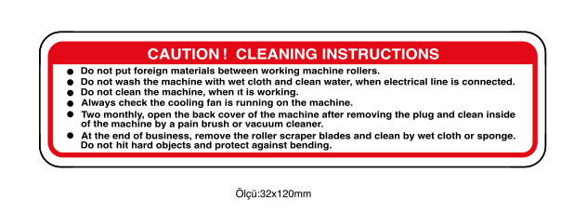
LABELS

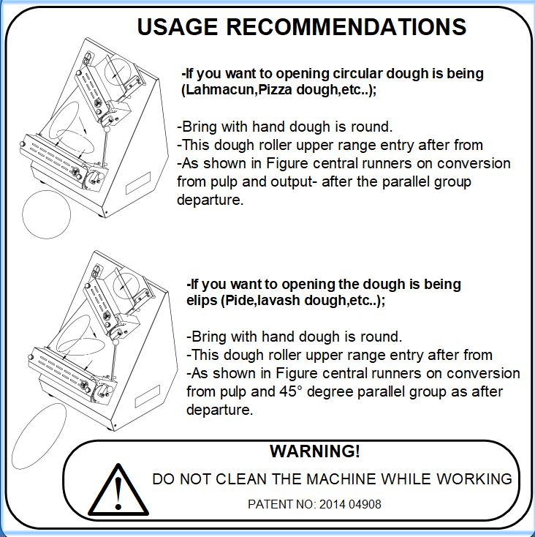

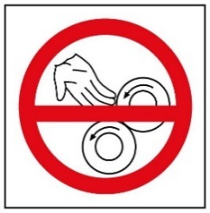

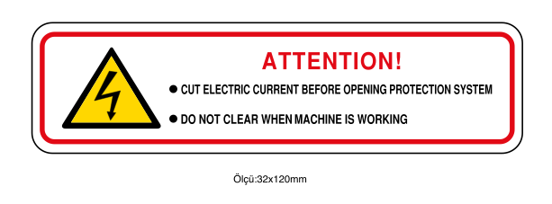

SECTION 2: INTRODUCTION OF MACHINE BODY COMPONENTS

2.1 Sheet Metal Assembly:
DETAIL A
SCALE 1: 4

DETAIL A
SCALE 1: 4

PART DESCRIPTION
1 | STAY BOLT (LEFT)
2 | GUARD SHEET THIMBLE
3 | BOARDING HANDLE
4 | STAY BOLT (RIGHT)
5 | GUARD SHEET (TOP ROLLER)
6 | GUARD SHEET (BOTTOM ROLLER)

2.2 Body Components:

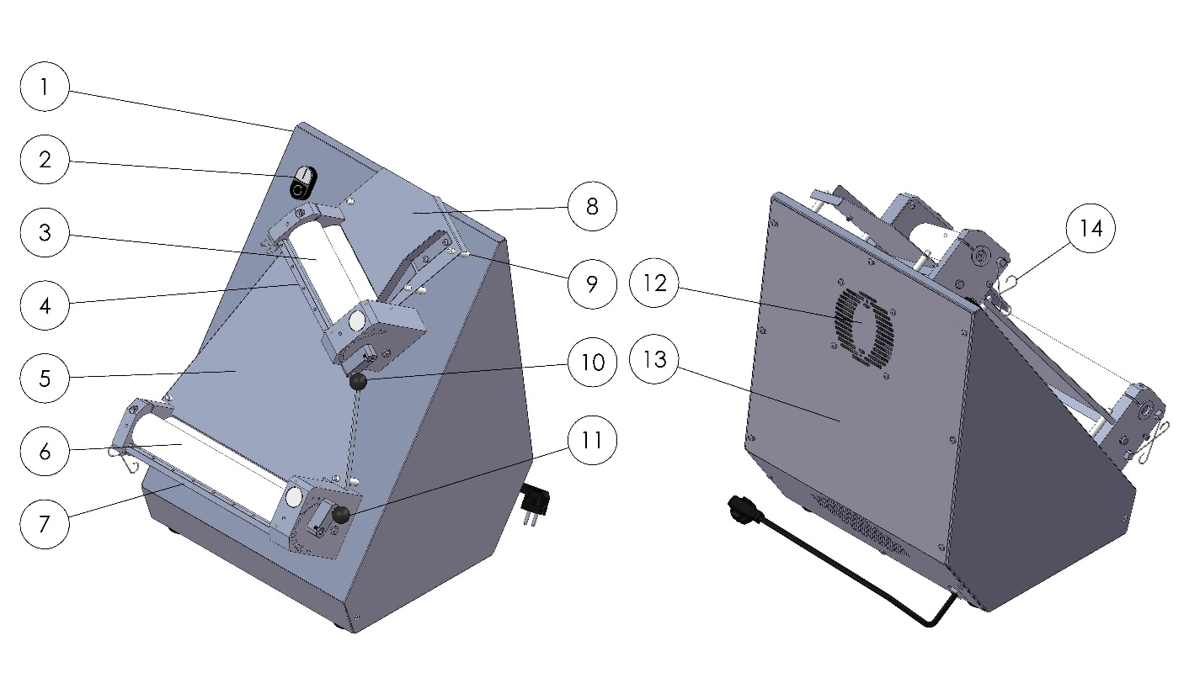

PART DERSCRIPTION
FRONT VIEW |  | REAR VIEW
1 | BODY | 8 | ENTRANCE SHEET
2 | START/STOP SWITCH | 9 | SHEET HOLDER PIN
3 | TOP ROLLER GROUP | 10 | TOP ROLLER ADJUST LEVER
4 | TOP ROLLER SCRAPERS | 11 | BOTTOM ROLLER ADJUST LEVER
5 | CENTRAL SHEET | 12 | COOLING FAN
6 | BOTTOM ROLLER GROUP | 13 | BACK COVER
7 | BOTTOM ROLLER SCRAPERS | 14 | ROLLER SCRAPERS WIRE

SECTION 3: INSTRUCTIONS FOR USE

3.1 Usage Recommendations:

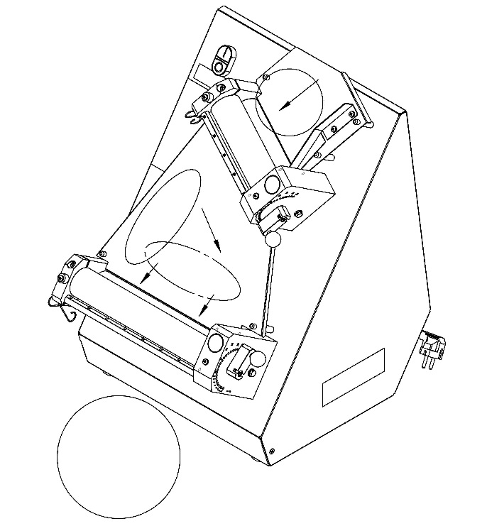
For Rolling Circular Dough (Lahmacun Dough Etc.);

- Compress the dough and make it circular.
- Pass through the dough to the upper roller gap.

Rotate the dough (shown in figure) then pass through the dough in parallel to the bottom roller gap.

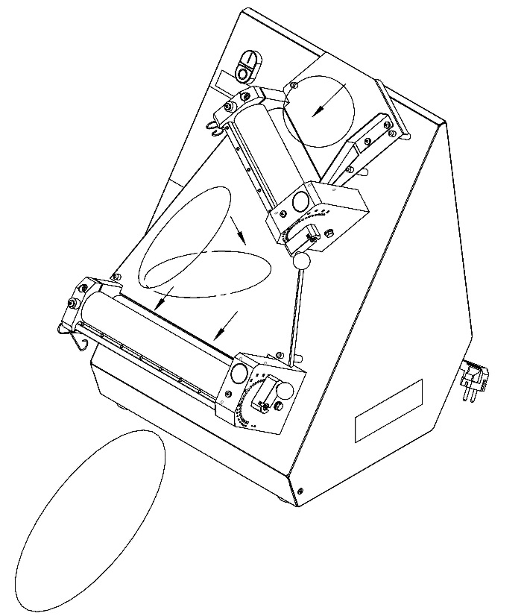
For Rolling Ellipse Dough (Pide Dough);

- Compress the dough and make it circular.
- Pass through the dough to the upper roller gap.

Rotate the dough (shown in figure) then pass through the dough in 45° to the bottom roller gap

3.2 Safety Warnings:

- Secure voltage is between 230 V and 240 V
- Set up on a straight floor.
- Single phase on operating.
- Don’t wipe the machine with a wet cloth when connect to plug.
- Cut electric current before opening protection system.
Check the air intake of the cooling fan daily.

3.3 Operating and Starting Instructions:

- Connect to monophase electrical supply.
- Push the “I” button.
- Adjust the roller space shown in picture. (This procedure adjusts the dough thickness and diameter)
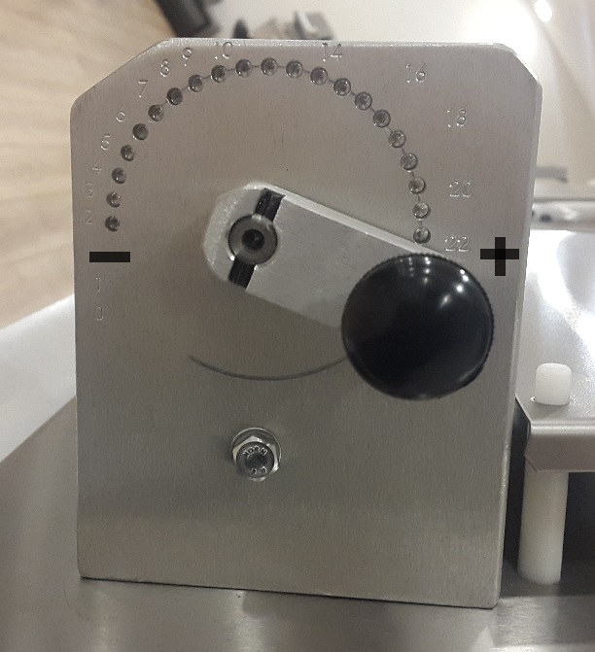

Adjust the dough thickness from “0” to “20” shown in figure.

- Pull the bakelite knob and rotate the knob to “+” or “-” direction.
- Rotate the knob to “+” direction for enlarge the dough thickness. Rotate the knob to “-” direction for reduce the dough thickness.
- Push the bakelite knob when the intended roller gap adjusted.

NOTE = Entrance roller gap advice to be bigger than the exit roller gap.

NOTE: Scrapers must be stretched

DESIRED PRODUCT | UPPER | BOTTOM
LAHMACUN
PIDE
PİZZA
TORTILLA BREAD
BOREK DOUGH

SECTION 4: MAINTENANCE

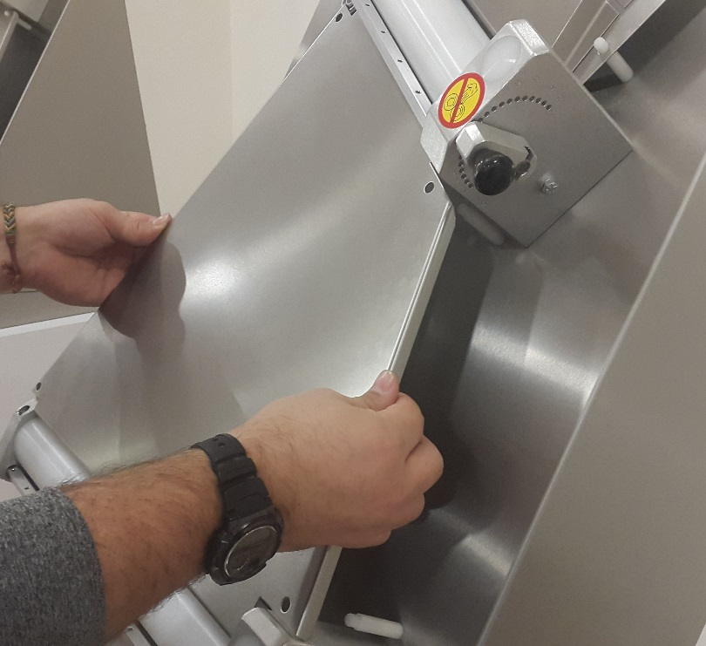
4.1 Exterior Body Maintenance:
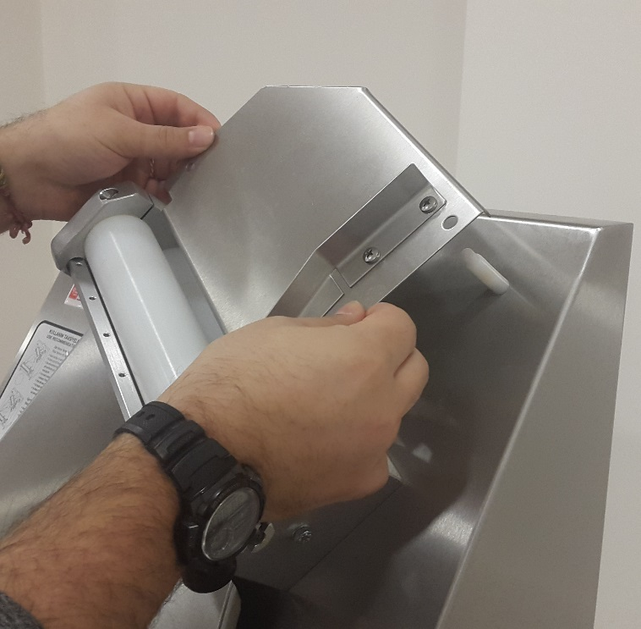
Pull up the entrance and central sheets shown in picture then clean the flour and crumbs. Stop the machine and unplug the electrical supply then clean with wet cloth. Don’t plug the electrical supply before the machine dry.

4.2 Scrapers Maintenance:
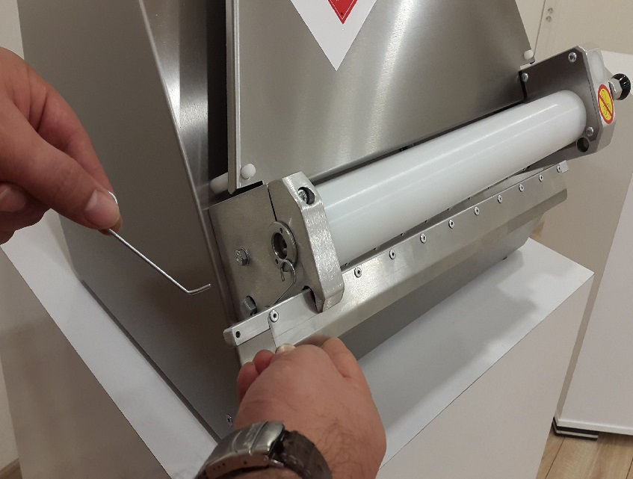
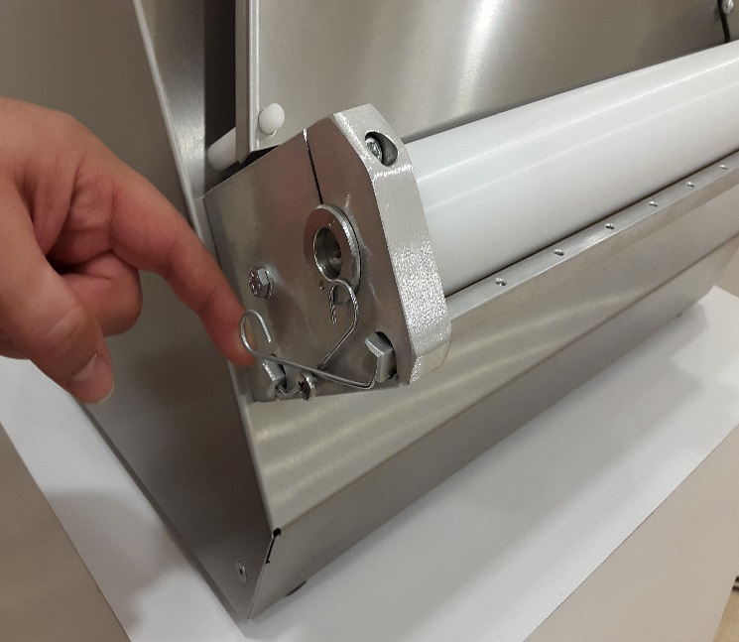
- Push up scrapers wire as shown in the figure
- Remove the scrapers from the hole as shown in the figure and clean the scrapers daily.

SECTION 5: SPARE PARTS MANUAL
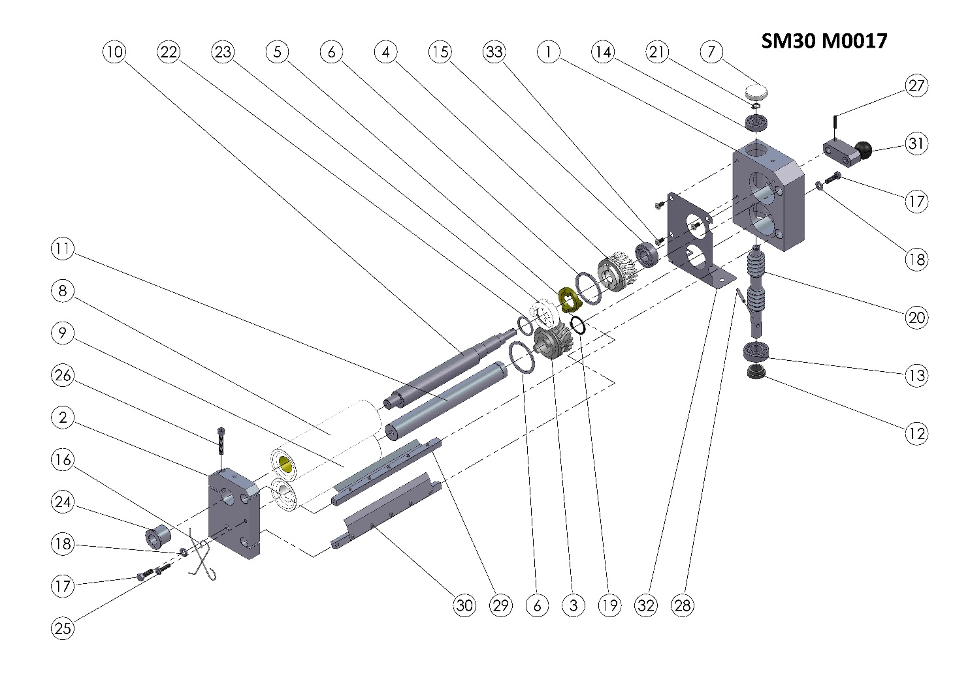
SM-30 M0017 (TOP ROLLER GROUP) SPARE PART LIST
ITEM NO. | SPARE PART NUMBER | DESCRIPTION OF THE SPARE PART | UNIT |  | ITEM NO. | SPARE PART NUMBER | DESCRIPTION OF THE SPARE PART | UNIT
1 | 00372 | GEARBOX | 1 |  | 18 | 00050 | WASHER | 2
2 | 00001 | ROLLER BEARING | 1 |  | 19 | 00089 | RING | 1
3 | 00338 | GEAR (MALE) | 1 |  | 20 | 00011 | WORM | 1
4 | 00007 | GEAR (FEMALE) | 1 |  | 21 | 00027 | RING | 1
5 | 00010 | CLUTCH | 1 |  | 22 | 00092 | O-RİNG | 1
6 | 00009 | RING | 2 |  | 23 | 00088 | CLUTCH | 1
7 | 00013 | COVER | 1 |  | 24 | 00086 | THIMBLE | 1
8 | 00014 | ROLLER (TOP) | 1 |  | 25 | 00047 | BOLT | 1
9 | 00015 | ROLLER (BOTTOM) | 1 |  | 26 | 00054 | BOLT | 1
10 | 00018 | SHAFT (TOP) | 1 |  | 27 | 00095 | PIN | 1
11 | 00019 | SHAFT (BOTTOM) | 1 |  | 28 | 00096 | PIN | 1
12 | 00022 | THIMBLE | 1 |  | 29 | 00333M | TOP ROLLER SCRAPPERS (TOP) | 1
13 | 00024 | BEARING | 1 |  | 30 | 00334M | TOP ROLLER SCRAPPERS (BOTTOM) | 1
14 | 00025 | BEARING | 1 |  | 31 | 00335M | ADJUSTING LEVER | 1
15 | 00026 | BEARING | 1 |  | 32 | 00385 | ROLLER GUARD SHEET | 1
16 | 00038 | SCRAPERS WIRE | 2 |  | 33 | 00340 | BOLT | 3
17 | 00041 | BOLT | 2 |  | 34

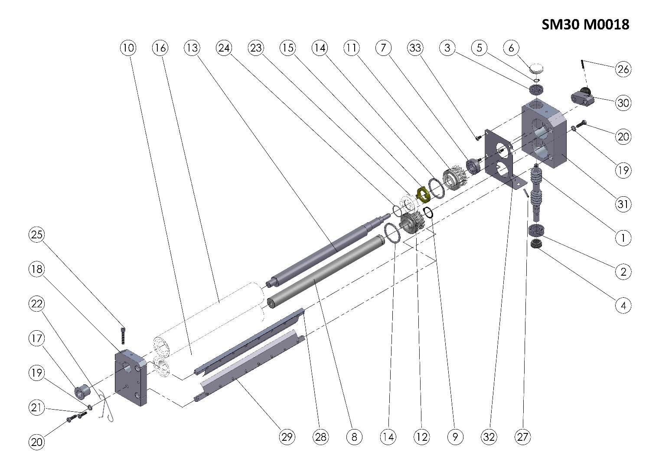

SM-30 M0018 (BOTTOM ROLLER GROUP) SPARE PARTS LIST
ITEM NO. | SPARE PART NUMBER | DESCRIPTION OF THE SPARE PART | UNIT |  | ITEM NO. | SPARE PART NUMBER | DESCRIPTION OF THE SPARE PART | UNIT
1 | 00011 | WORM | 1 |  | 18 | 00001 | ROLLER BEARING | 1
2 | 00024 | BEARING | 1 |  | 19 | 00050 | WASHER | 2
3 | 00025 | BEARING | 1 |  | 20 | 00041 | BOLT | 2
4 | 00022 | THIMBLE | 1 |  | 21 | 00047 | BOLT | 1
5 | 00027 | RING | 1 |  | 22 | 00038 | SCRAPERS WIRE | 2
6 | 00013 | COVER | 1 |  | 23 | 00088 | CLUTCH | 1
7 | 00026 | BEARING | 1 |  | 24 | 00092 | O-RİNG | 1
8 | 00021 | SHAFT (BOTTOM) | 1 |  | 25 | 00054 | BOLT | 1
9 | 00089 | RING | 1 |  | 26 | 00095 | PIM | 1
10 | 00017 | ROLLER (BOTTOM) | 1 |  | 27 | 00096 | PIM | 1
11 | 00007 | GEAR (FEMALE) | 1 |  | 28 | 00336M | SCRAPERS (TOP) | 1
12 | 00338 | GEAR (MALE) | 1 |  | 29 | 00337M | SCRAPERS (BOTTOM) | 1
13 | 00020 | SHAFT (TOP) | 1 |  | 30 | 00335M | ADJUSTING LEVER | 1
14 | 00009 | RING | 2 |  | 31 | 00372 | GEARBOX | 1
15 | 00010 | CLUTCH | 1 |  | 32 | 00385 | ROLLER GUARD SHEET | 1
16 | 00016 | ROLLER (TOP) | 1 |  | 33 | 00340 | BOLT | 3
17 | 00086 | THIMBLE | 1 |  | 34

BODY

SM-30 SMART SPARE PARTS LIST
ITEM NO. | SPARE PART NUMBER | DESCRIPTION OF THE SPARE PART | UNIT |  | ITEM NO. | SPARE PART NUMBER | DESCRIPTION OF THE SPARE PART | UNIT
1 | 00085 | PULLEY | 1 |  | 19 | 00006 | WASHER | 2
2 | 00005 | PULLEY | 1 |  | 20 | 00042 | WASHER | 12
3 | 00055 | BUTTON | 1 |  | 21 | 00041 | BOLT | 12
4 | 00057 | FUSE | 1 |  | 22 | 00051 | WASHER | 7
5 | 00056 | CONTACTOR | 1 |  | 23 | 00049 | BOLT | 7
6 | 00132 | CENTRAL SHEET PIN (LONG) | 4 |  | 24 | 00050 | WASHER | 10
7 | 00133 | ENTRANCE SHEET PIN (SHORT) | 3 |  | 25 | 01258 | WASHER | 3
8 | 00067 | CENTRAL SHEET | 1 |  | 26 | 01959 | NUT | 3
9 | 00097 | RECORD | 1 |  | 27 | 00355 | POWER CABLE | 1
10 | SM30 M0017 | TOP ROLLER GROUP (KOMPLE) | 1 |  | 28 | 00057M | BODY | 1
11 | SM30 M0018 | BOTTOM ROLLER GROUP (KOMPLE) | 1 |  | 29 | 00338M | SM30 ENTRANCE SHEET | 1
12 | 00354 | LEG | 4 |  | 30 | 00058M | ENGİNE | 1
13 | 00476 | BOLT | 3 |  | 31 | 00059M | BACK COVER | 1
14 | 00046 | BOLT | 16 |  | 32 | 00059 | FAN | 1
15 | 00424 | V BELT | 1 |  | 33 | 00077 | TOP PROTECTION SHEET | 1
16 | 00028 | V BELT | 1 |  | 34 | 00409 | THIMBLE | 2
17 | 01960 | WASHER | 4 |  | 35 | 00047 | BOLT | 2
18 | 00298 | NUT | 4 |  | 36 | 00078 | UNDER PROTECTION SHEET | 1

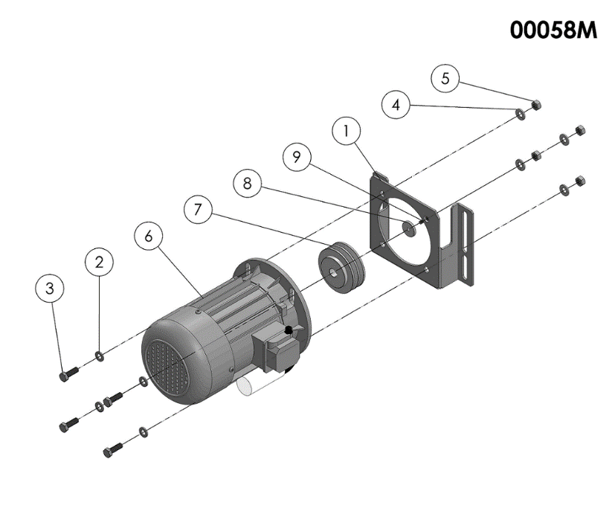

058M SPARE PARTS LIST
ITEM NO. | SPARE PART NUMBER | DESCRIPTION OF THE SPARE PART | UNIT
1 | 00347 | ENGINE CONNECT SHEET | 1
2 | 01963 | WASHER | 4
3 | 04072 | BOLT | 4
4 | 01961 | WASHER | 4
5 | 01959 | NUT | 4
6 | 00023 | ENGINE | 1
7 | 00094 | PULLEY | 1
8 | 00098 | WASHER | 1
9 | 00049 | BOLT | 1

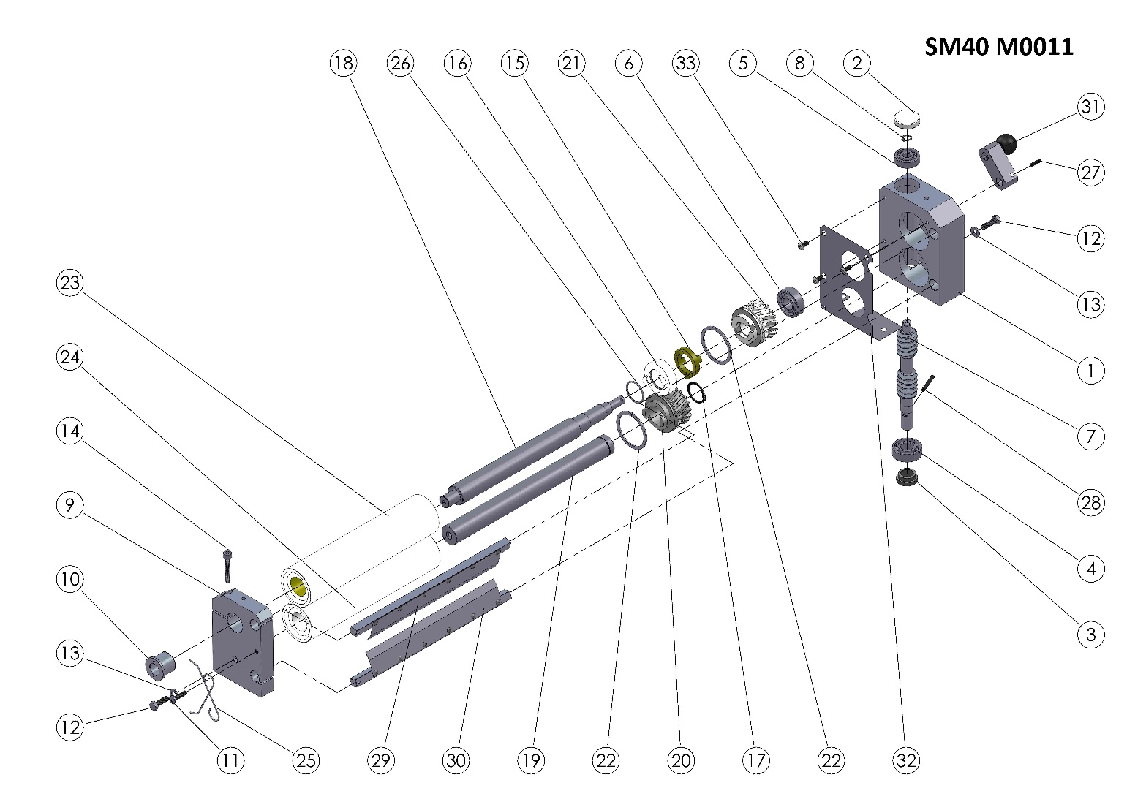

SM-40 M0011 (TOP ROLLER GROUP) SPARE PART LIST

ITEM | SPARE PART NUMBER | DESCRIPTION OF THE SPARE PART | UNIT |  | ITEM | SPARE PART NUMBER | DESCRIPTION OF THE SPARE PART | UNIT
1 | 00372 | GEAR BOX | 1 |  | 18 | 00103 | UPPER SHAFT | 1
2 | 00013 | COVER | 1 |  | 19 | 00105 | BOTTOM SHAFT | 1
3 | 00022 | THIMBLE | 1 |  | 20 | 00338 | GEAR (MALE) | 1
4 | 00024 | BEARING | 1 |  | 21 | 00007 | GEAR (FEMALE) | 1
5 | 00025 | BEARING | 1 |  | 22 | 00009 | RING | 2
6 | 00026 | BEARING | 1 |  | 23 | 00134 | ROLLER (TOP) | 1
7 | 00011 | WORM | 1 |  | 24 | 00135 | ROLLER (BOTTOM) | 1
8 | 00027 | RING | 1 |  | 25 | 00038 | SCRAPERS WIRE | 2
9 | 00001 | ROLLER BEARING | 1 |  | 26 | 00092 | O-RİNG | 1
10 | 00086 | THIMBLE | 1 |  | 27 | 00095 | PIN | 1
11 | 00047 | BOLT | 1 |  | 28 | 00096 | PIN | 1
12 | 00041 | BOLT | 2 |  | 29 | 00339M | ROLLER SCRAPER (TOP) | 1
13 | 00050 | WASHER | 2 |  | 30 | 00340M | ROLLER SCRAPER (BOTTOM) | 1
14 | 00054 | BOLT | 1 |  | 31 | 00335M | ADJUSTING LEVER | 1
15 | 00010 | CLUTCH | 1 |  | 32 | 00385 | ROLLER GUARD SHEET | 1
16 | 00088 | CLUTCH | 1 |  | 33 | 00340 | BOLT | 3
17 | 00089 | RING | 1 |  | 34

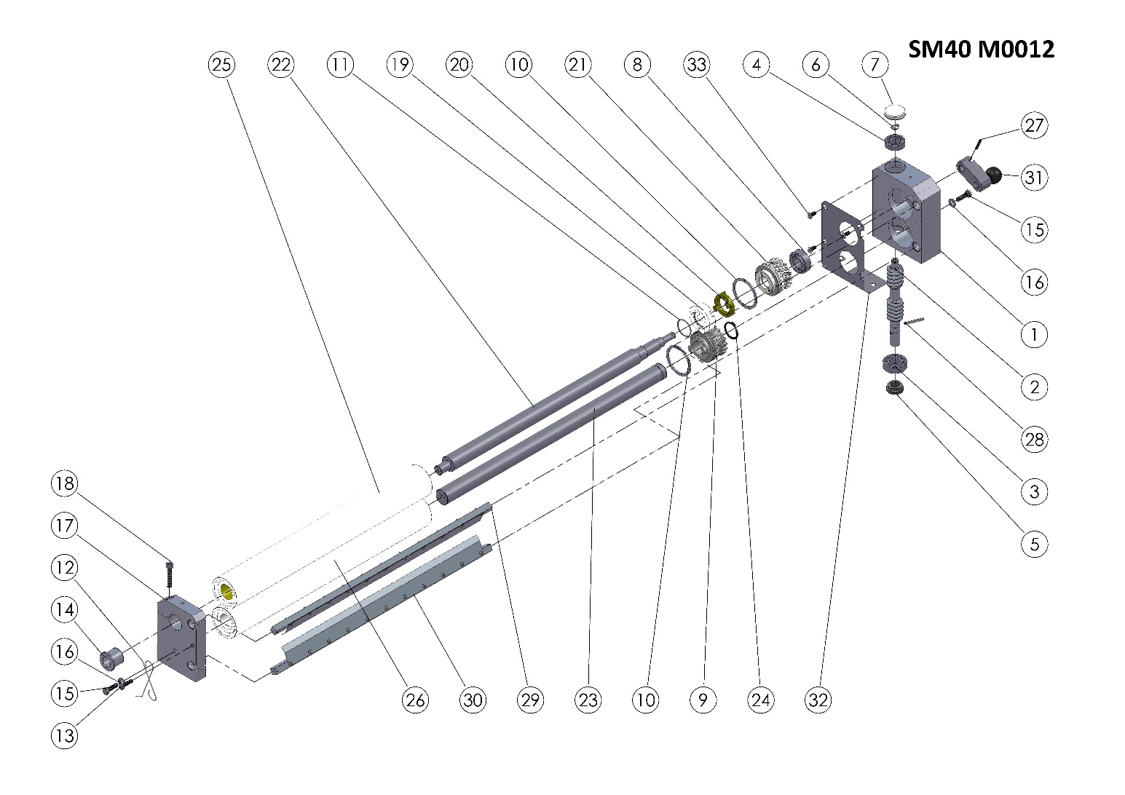

SM-40 M0012 (BOTTOM ROLLER GROUP) SPARE PARTS LIST
ITEM NO. | SPARE PART NUMBER | DESCRIPTION OF THE SPARE PART | UNIT |  | ITEM NO. | SPARE PART NUMBER | DESCRIPTION OF THE SPARE PART | UNIT
1 | 00372 | GEAR BOX | 1 |  | 18 | 00054 | BOLT | 1
2 | 00011 | WORM | 1 |  | 19 | 00088 | CLUTCH | 1
3 | 00024 | BEARING | 1 |  | 20 | 00010 | CLUTCH | 1
4 | 00025 | BEARING | 1 |  | 21 | 00007 | GEAR (FEMALE) | 1
5 | 00022 | THIMBLE | 1 |  | 22 | 00102 | ROLLER SHAFT (TOP) | 1
6 | 00027 | RING | 1 |  | 23 | 00104 | ROLLER SHAFT (BOTTOM) | 1
7 | 00013 | COVER | 1 |  | 24 | 00089 | RING | 1
8 | 00026 | ROLLER | 1 |  | 25 | 00136 | ROLLER | 1
9 | 00338 | GEAR (MALE) | 1 |  | 26 | 00137 | ROLLER | 1
10 | 00009 | RING | 2 |  | 27 | 00095 | PIN | 1
11 | 00092 | O-RİNG | 1 |  | 28 | 00096 | PIN | 1
12 | 00038 | SCRAPERS WIRE | 2 |  | 29 | 00341M | SCRAPER (TOP) | 1
13 | 00047 | BOLT | 1 |  | 30 | 00342M | SCRAPER (BOTTOM) | 1
14 | 00086 | THIMBLE | 1 |  | 31 | 00335M | ADJUSTING LEVER | 1
15 | 00041 | BOLT | 2 |  | 32 | 00385 | ROLLER GUARD SHEET | 1
16 | 00050 | WASHER | 2 |  | 33 | 00340 | BOLT | 3
17 | 00001 | ROLLER BEARING | 1 |  | 34

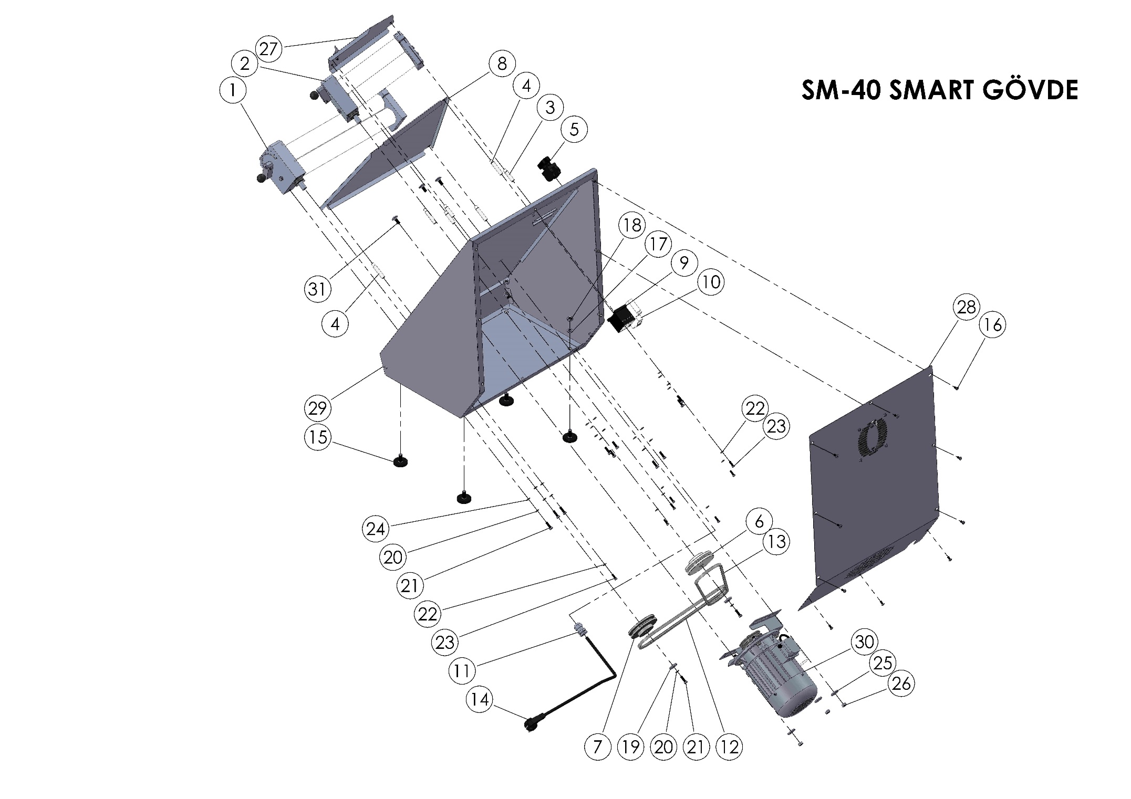

SM-40 SMART SPARE PARTS LIST
ITEM | SPARE PART NUMBER | DESCRIPTION OF THE SPARE PART | UNIT
1 | SM-40 M0012 | BOTTOM ROLLER GROUP | 1
2 | SM-40 M0011 | TOP ROLLER GROUP | 1
3 | 00133 | ENTRANCE SHEET PIN (SHORT) | 3
4 | 00132 | CENTRAL SHEET PIN (LONG) | 4
5 | 00055 | BUTTON | 1
6 | 00085 | PULLEY | 1
7 | 00005 | PULLEY | 1
8 | 00110 | CENTRAL SHEET | 1
9 | 00056 | CONTACTOR | 1
10 | 00057 | FUSE | 1
11 | 00097 | RECORD | 1
12 | 00424 | V BELT | 1
13 | 00426 | V BELT | 1
14 | 00355 | POWER CABLE | 1
15 | 00354 | LEG | 4
16 | 00046 | BOLT | 10
17 | 01960 | WASHER | 4
18 | 00298 | NUT | 4
19 | 00006 | WASHER | 2
20 | 00042 | WASHER | 12
21 | 00041 | BOLT | 12
22 | 00051 | WASHER | 7
23 | 00049 | BOLT | 7
24 | 00050 | WASHER | 10
25 | 01258 | WASHER | 3
26 | 01959 | NUT | 3
27 | 00343M | ENTRANCE SHEET | 1
28 | 00061M | BACK COVER | 1
29 | 00062M | BODY | 1
30 | 00058M | ENGINE | 1
31 | 00476 | BOLT | 3

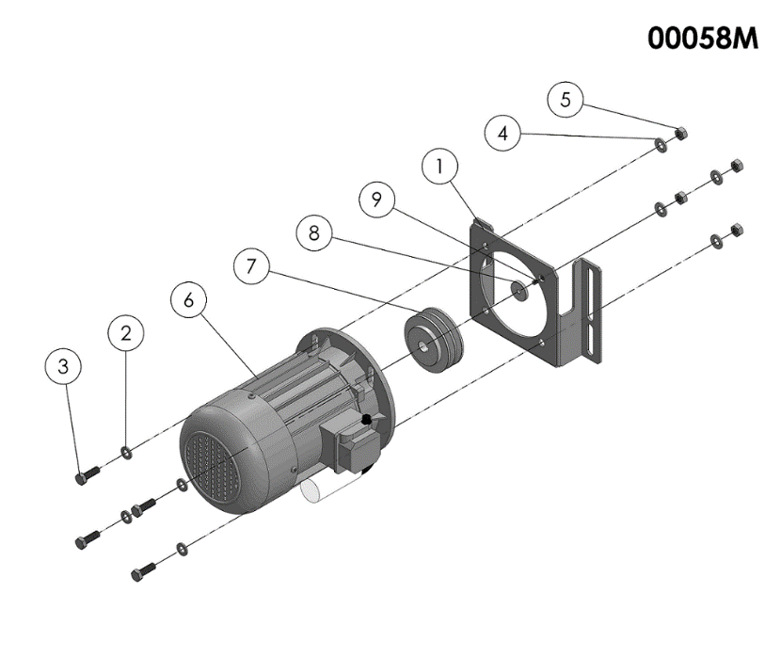

00058M SPARE PARTS LIST
ITEM | SPARE PART NUMBER | DESCRIPTION OF THE SPARE PART | UNIT
1 | 00347 | ENGINE CONNECT SHEET | 1
2 | 01963 | WASHER | 4
3 | 04072 | BOLT | 4
4 | 01961 | WASHER | 4
5 | 01959 | NUT | 4
6 | 00023 | ENGINE | 1
7 | 00094 | PULLEY | 1
8 | 00098 | WASHER | 1
9 | 00049 | BOLT | 1

SECTION 6: ELECTRICAL DIAGRAM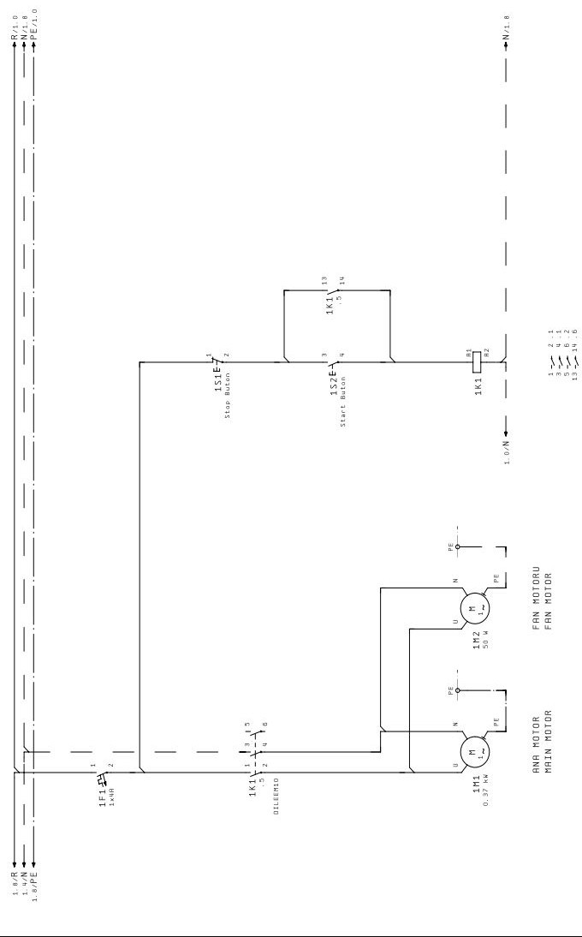

Manufacturing Company: ŞENGÜN MAKİNA İNŞAAT ve KIRTASİYE SAN. TİC. LTD. ŞTİ.

İkitelli Organize Sanayi Bölgesi Mah. Atatürk Bulvarı Pufa İş Merkezi No:98 Bodrum Kat:2-3 Başakşehir / İstanbul | Türkiye
Tel: +90 212 671 23 23 (Pbx) Tel 2: +90 212 671 84 24 Fax: +90 212 671 88 28
GHX: +90 533 957 14 53
E-Mail: usta@hamurex.com.tr
Web: www.hamurex.com.tr

